
Planning a sequenced curriculum to ensure all children make progress and are ready for the next stage of their education.
Reception Curriculum
St. Alban’s Catholic Primary School
© EY2P Early Years 2 Primary LLP www.ey2p.org

EYFS: Reception Sequenced Curriculum Implementation
Age Related Expectations * Teaching and learning to be differentiated through short term planning, driven by assessment
Consolidation and revisit of key skills, knowledge and understanding through continuous and enhanced provision
 | Autumn 1 | Autumn 2 | Spring 1 | Spring 2 | Summer 1 | Summer 2
Overarching Themes | Getting to  Know You  Our Wonderful World | Autumn  Celebrations  Community | Superheroes  Healthy Body, Happy Me | Spring  Traditional Tales | Growing  Changes over time | Seaside  We’re off on adventures!
Understanding of the World – Past and Present | 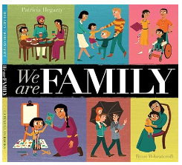 | 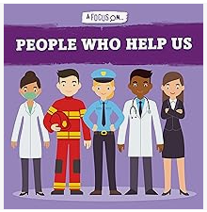 | 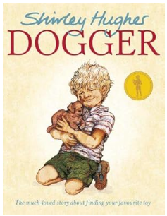 | 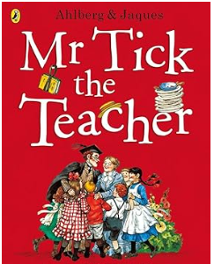 | 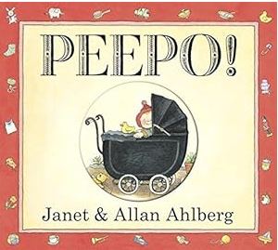 | 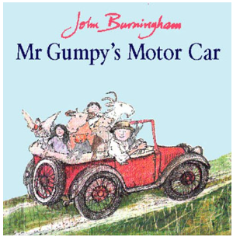
Understanding of the World – People and Communities | 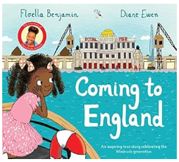 | 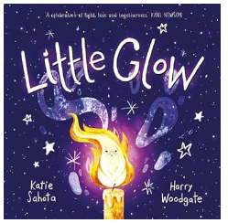 | 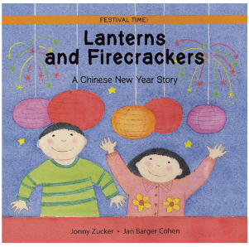 | 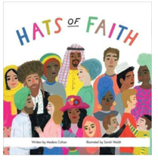 | 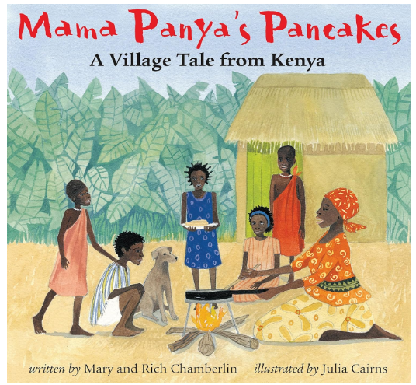 | 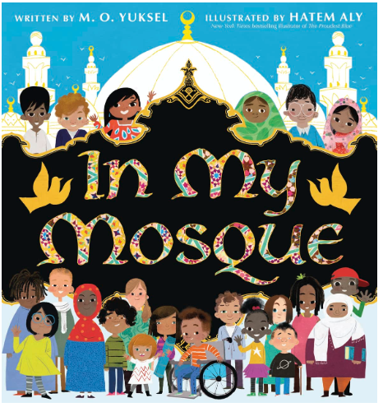
Understanding of the World – The World | 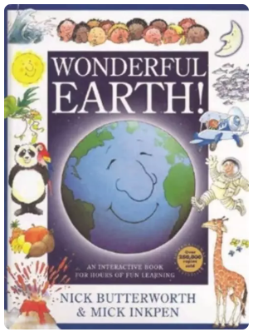 | 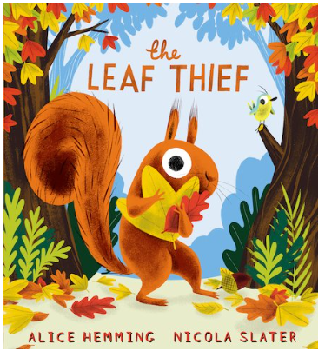 | 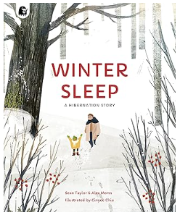 | 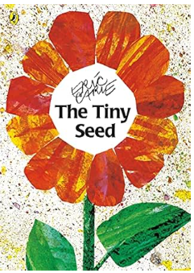 | 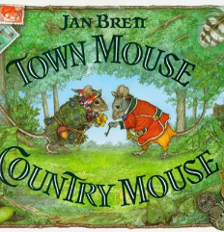 | 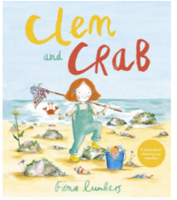
Enrichments  Trips/Visitors  Celebrations / Festivals / Special Events | Visitors:  Our School Family:  - Headteacher  - Site Manager  - School Cook  - Parish Priest  - Year 6 buddies  Celebrations & Events:  - Birthdays  - Season of Creation  - Black History Month | Visitors:  - Library Van  - Travelling Pantomime Show (EYFS & KS1)  Trip:  - Autumn Walk  Celebrations & Events:  - Birthdays  - Diwali  - Bonfire Night  - Remembrance Sunday  - Christmas | Visitors:  - Dentist / Doctor / Nurse  Trip:  - Walk to the local shop  Celebrations & Events:  - Birthdays  - Chinese New Year  - Internet Safety Day  - Shrove Tuesday  - Ash Wednesday  - Lent | Trip:  - Expedition to woodland area at the back of school  Celebrations & Events:  - Birthdays  - World Book Day  - Mothering Sunday  - Eid al-Fitr  - Holy Week, Good Friday and Easter Sunday. | Trip:  - Macclesfield Library  Celebrations & Events:  - Birthdays  - Ascension Day  - Marion Procession | Trip:  - Peak Wildlife Park  Visitors:  - Year 1 Teachers  Celebrations & Events:  - Birthdays  - Eid al-Adha  - St. Alban’s Day  - Sport’s Day  - Father’s Day  - Transition days to Y1
Understanding of the World -themes covered | - Home Corner – Role play within a familiar environment  - Small World Resources – Farm, Train track  - All About Me & My Family  - Practical ways to look after our world: Litter picking; composting.  - Little People, Big Dreams | - What happens in Autumn?  - Nature Table  - Weather and seasons  - Traditions and celebrations  - People who help us – The Jolly Christmas Postman | - Hibernation  - Where does our food come from? (Life in other countries)  - The World Came to My Place today | - The 5 senses  - Seasonal changes - Spring  - Town and Countryside  - Minibeasts and microhabitats  - Draw information from a simple map | - Geographical Features – Woodlands and Forests  - My History Box  - Lifecycles  - Geographical Feature – Pond  - Growing Plants | - Special places – The Church and The Mosque  - Visiting different countries through books  - Geographical Features – Seashore  - Concept: Floating and sinking  - Celebration assembly – changes through the seasons

 |  | Autumn 1 |  | Autumn 2 |  | Spring 1 |  | Spring 2 |  | Summer 1 |  | Summer 2
Personal, Social, Emotional Development  Physical Development |  | 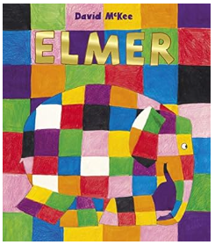 |  | 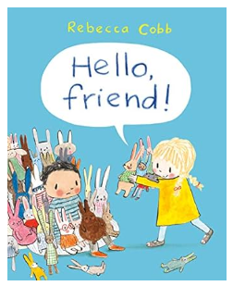 |  | 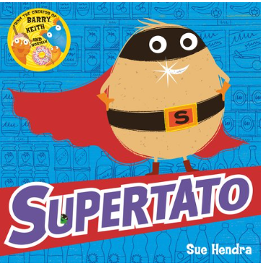 |  | 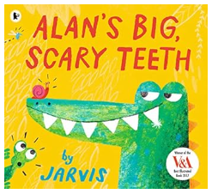 |  | 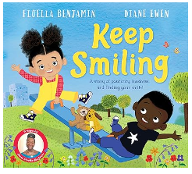 |  | 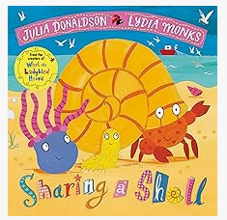
PSED / PD -themes covered  RHE:  Ten Ten Life to The Full |  | What makes me special?  It’s good to be different!  Module 1 Created and Loved by God:  Unit 1 - Religious Understanding:  Handmade with Love |  | What is a good friend?  Pants are Private  Module 1 Created and Loved by God:  Unit 2 - Me, My Body, My Health:  I am Me  Heads, Shoulders, Knees and Toes  Ready, Teddy? |  | How to be a healthy hero  Healthy food and exercise  How to keep well  Module 1 Created and Loved by God:  Unit 3 – Emotional Well-Being:  I Like, You Like, We all Like!  Good Feelings, Bad Feelings  Let’s Get Real  Unit 4 – Life Cycles:  Growing Up |  | Oral hygiene  Pants are Private  Module 2 Created to Love Others  Unit 1 – Religious Understanding:  Role Model  Unit 2 – Personal Relationships:  Who’s Who?  You’ve Got a Friend in Me  Forever Friends |  | Friendship and kindness  Module 2 Created to Love Others  Unit 3 – Keeping Safe:  Safe Inside and Out  My Body, My Rules  Feeling Poorly  People Who Help Us |  | Friendship and sharing  Pants are Private  Module 3: Created to Live in Community  Unit 1 – Religious Understanding:  God Is Love  Loving God, Loving Others  Unit 2 – Living in the Wider World:  Me, You, Us.
RE:  The Way, The Truth and The Life |  | F1: God’s World  • Know that God made the world.  • Know that God has asked us to care for the world.  • Know that God loves and cares for each one of us.  • Know that God made each one of us different and special.  + Learning prayers  + Our School Values  + Creation Dance  + Prayer and Liturgy |  | F2: God’s Family  • Know that the angel Gabriel asked Mary to be the mother of God’s son.  • Know that in Advent we prepare to celebrate Christmas.  • Know the story of the birth of Jesus.  • Know that shepherds were the first to hear about the birth of Jesus.  + Advent preparations  + Nativity  + Prayer and Liturgy |  | F3: Getting to know Jesus  • Know about the loss and finding of Jesus in the Temple.  • Know that Jesus chose friends to help him  • Know that Jesus has great love for each one of us.  • Know that Jesus healed the man at the Pool of Bethesda.  + Exploring maps of places of religious importance  + Prayer and Liturgy |  | F4: Sorrow and joy  • Understand that we should try to be kind and not hurt others.  • Learn to say sorry when we hurt someone and ask Jesus to help us to do this.  • Know that Jesus forgave those who hurt him.  • Know that Jesus died on Good Friday but that was not the end.  + Easter preparations  + Prayer and Liturgy |  | F5: New Life  • Begin to understand that we celebrate Easter because Jesus rose from the dead.  • Begin to understand that Jesus gives a special gift of joy and peace.  • Know the story of Jesus going back to his Father in heaven.  • Know that Mary is the Mother of Jesus and our Mother.  + Prayer and Liturgy |  | F6: The Church  • Know that we belong to our Church family.  • Know that the members of the Church are called Christians.  • Know why Sunday is a special day for the Church family.  • Know about the Sacrament of Baptism.  + Prayer and Liturgy
 | Essential Letters and Sounds – Phonics
 | Autumn 1 |  | Autumn 2 |  | Spring 1 |  | Spring 2 |  | Summer 1 |  | Summer 2
 | Phase 2  /s/ /a/ /t/ /p/ /i/ /n/ /m/ /d/ /g/ /o/ /c/ /k/ /e/ /u/ /r/ /s/ /h/ /b/ /f/ /l/  HRSW  I, the, no put, of, is to, go, into, pull as, his |  | Phase 3  /j/ /v/ /w/ /x/ /y/ /z/ /qu/ /ch/ /sh/ /th/ (voiced and unvoiced) /ng/ /nk/ /ai/ /ee/ /igh/ /oa/ –es (where there is no change to the root word)  HRSW  he, she, buses we, me, be push was, her my, you |  | Phase 3 – 4  /oo/ (book) /ar/ /ur/ /oo/ (food) /or/ /ow/ /oi/ /ear/ /air/ /ure/ /er/ <ow> /oa/  HRSW  they, all, are ball, tall when, what |  | Phase 3 – 4  Review weeks  HRSW  said, so, have were, out, like some, come, there little, one, do children, love |  | Phase 4  CVCC –ed /ed/  CCVC –ed /t/  CCVCC –ed /d/  CCCVC Assess  CCCVCC –er –est |  | Phase 5 Introduction  <ay> <ou> <ie> <ea> -le <oy> <ir> <ue> <aw> <wh> <ph> <ew> <oe> <ay> <ey> <a-e> <e-e> <i-e> <o-e> <u-e> <c>  HRSW  oh, their people, Mr, Mrs your, ask, should, would, could, asked house, mouse, water want, very

Drawing Club
Drawing Club incorporates story sharing, speaking and listening, drawing, writing, vocabulary, mathematics, imagination and collaboration. Each week we choose a focus story, tale or animation that will spark the children’s interest and imagination. The children learn new vocabulary linked to the story and are invited to Drawing Club. In Drawing Club the children may draw a character, setting or an event / adventure. They can innovate their drawings and add secret passwords, magic powers or spells, hidden symbols, letters or numerals. Throughout the Reception year, the codes progress in complexity and skill. During the sessions, children may write codes related to the sounds we have been learning in phonics to CVC words and writing sentences. Please see separate planning overview for the current year’s chosen texts.

PE
Autumn 1 | Autumn 2 | Spring 1 | Spring 2 | Summer 1 | Summer 2
Dance - Expression through music and movement  Culminating in a performance of The Creation Dance. | Ball skills – Developing hand-eye and foot-eye coordination.  Write Dance and Dough Disco | Gymnastics - Exploring balance and different ways of travelling.  Story themed Yoga | Circuits – Developing fitness and agility. Children to plan and create their own circuit activities using a range of equipment | Athletics – Developing running, relay and teamwork skills | Sport’s Day Practice / Team games

NCETM – Number and Numerical patterns
Autumn 1 | Autumn 2 | Spring 1 | Spring 2 | Summer 1 | Summer 2
Mastering Number NCETM  * Subitising: Perceptually within 3  * Cardinality: Counting strategies incl. 1:1 correspondence  * Composition: All numbers are made of 1s  * Comparison: Use the language of comparison, including ‘more than’ and ‘fewer than’ | Mastering Number NCETM  * Subitising within 5  * Cardinality of 5, linking this to dice patterns and 5 fingers on 1 hand  * Composition of numbers within 5. ‘Wholes’ and ‘Parts.’  * Comparison of sets using a variety of strategies. Introduction to ‘same’ and ‘equal.’ | Mastering Number NCETM  * Subitising: Patterns within 5. Patterns beyond 5, where 5 is a clear part.  * Cardinality: verbal counting to 20. Using fingers to represent quantities 5-10  * Composition: numbers within 10 can be composed of ‘5 and a bit’.  * Comparison: make unequal sets equal. | Mastering Number NCETM  * Subitising symmetrical patterns, linking this to ‘doubles’.  * Cardinality of larger numbers within 10  & counting pattern beyond 20  * Composition of numbers within 10 and of odd and even numbers, incl. the ‘shape’ of these numbers.  * Comparison of numbers, reasoning about which has more. | Mastering Number NCETM  * Subitising of arrangements incl ‘1 more’ or ‘doubles.’ Identify when patterns show the same number in a different arrangement / similar but have a different number  * Cardinality: to develop verbal counting to 20 and beyond, incl. counting from different numbers.  * Composition of 10.  * Comparison: order sets of objects, linking to ordinal number system. | Mastering Number NCETM  Children will consolidate their understanding of concepts previously taught through working in a variety of contexts and with different numbers.
White Rose – Shape, Space and Measure
Shape, Space and Measure White Rose:  Phase 1: Just Like Me  * Compare size, mass and capacity (big, little, large, small, tall, short, long).  * Same and Different  * Simple Patterns (AB). | Shape, Space and Measure White Rose:  Phase 2: It’s Me 1, 2, 3!  * Circles & Triangles  * Spatial awareness (positional language)  Phase 3: Light and Dark  * Shapes with 4 sides  * Night & Day | Shape, Space and Measure White Rose:  Phase 4: Alive in 5!  * Compare mass  * Compare Capacity  Phase 5: Growing 6, 7, 8.  * Length & Height  * Days of the week and time | Shape, Space and Measure White Rose:  Phase 6: Building 9 and 10.  * 3D Shapes  * Pattern (AAB, ABB, AABB, AABBB).  * Consolidation | Shape, Space and Measure White Rose:  Phase 7: To 20 & beyond.  * Spatial Reasoning 1: Matching shape arrangements.  Phase 8: First, Then, Now.  * SR 2: Make new shapes. | Shape, Space and Measure White Rose:  Phase 9: Find My Pattern  * Spatial Reasoning 3: Look from different positions and use positional language to describe where objects are in relation to other items.  Phase 10: On the Move  * Spatial Reasoning 4: Children use simple maps and create their own maps to represent the models they build, familiar places and places in stories.

Charanga – Music
Autumn 1 | Autumn 2 | Spring 1 | Spring 2 | Summer 1 | Summer 2
Musical Composition: The Egg Travels (Dinosaur Score)  Charanga Music School focus – The Name Song | Musical Composition: Somewhere Only We Know Instrumental  Charanga Music School focus – Things for Fingers | Musical Composition:  Storm – Vanessa-Mae  Charanga Music School  i) Wheels on the Bus  ii) Alphabet song | Musical Composition:  The Four Seasons - Vivaldi Charanga Music – Help Me Plant the Seeds song | Musical Composition:  Flight of the Bumblebee - Rimsky Korsakov  Charanga Music School focus – Strawberries and Cherries | Musical Compositions:  i) The Carnival of the Animals - Saint-Saens  ii) Water Music – Handel  Charanga Music School focus – If You’re Happy and You Know It

Kapow – Art & Design Technology
Autumn 1 | Autumn 2 | Spring 1 |  | Spring 2 | Summer 1 |  | Summer 2
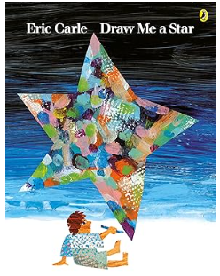 | 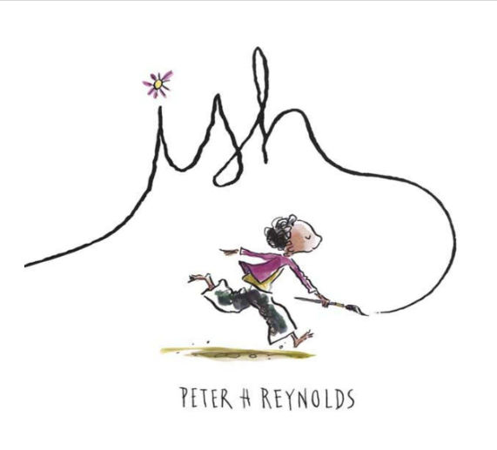 | 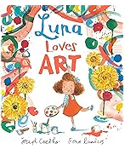 |  | 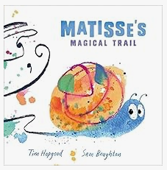 | 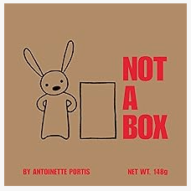 |  | 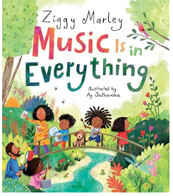
Art - Drawing: Marvellous marks  Exploring mark making through different drawing materials. Beginning to draw from observation using faces and self-portraits as a stimulus. | Art - Painting and mixed media: Paint my world Exploring painting techniques through nature, music, collaborative work. Developing creativity through child-led exploration of mixed-media and transient art. | Art – Seasonal Art and Crafts |  | Art – Seasonal Art and Crafts | Art – Seasonal Art and Crafts |  | Art - Sculpture and 3D: Creation station  Exploring sculptural qualities of malleable materials and natural objects; developing the use of tools and joining techniques; making clay animal sculptures.
D&T – Seasonal Projects | D&T – Seasonal Projects and Christmas crafts | D&T - Cooking and nutrition: Soup  Exploring the differences between fruits and vegetables using their senses Listen to the story ‘The best pumpkin soup’ and discuss the key ingredients the characters used before developing a class-based vegetable soup recipe. |  | D& T - Structures: Junk modelling  Exploring and learning about various types of permanent and temporary join. They are encouraged to tinker using a combination of materials and joining techniques in the junk modelling area. | D& T - Textiles: Bookmarks  Practising threading and weaving techniques using various materials and objects. They look at the history of the bookmark from Victorian times versus modern-day styles. The pupils apply their knowledge and skills to design and sew their own bookmarks. |  | D&T – Seasonal Projects
Sequenced curriculum INTENT for: COMMUNICATION & LANGUAGE: □ Listening, Attention & Understanding □ Speaking
Educational Programme: The development of children’s spoken language underpins all seven areas of learning and development. Children’s back-and-forth interactions from an early age form the foundations for language and cognitive development. The number and quality of the conversations they have with adults and peers throughout the day in a language-rich environment is crucial. By commenting on what children are interested in or doing, and echoing back what they say with new vocabulary added, practitioners will build children's language effectively. Reading frequently to children, and engaging them actively in stories, non-fiction, rhymes and poems, and then providing them with extensive opportunities to use and embed new words in a range of contexts, will give children the opportunity to thrive. Through conversation, story-telling and role play, where children share their ideas with support and modelling from their teacher, and sensitive questioning that invites them to elaborate, children become comfortable using a rich range of vocabulary and language structures
Autumn |  |  | Spring |  |  | Summer
Learning Priorities: Linked to Development Matters 2020
Listening, Attention and Understanding  - Understand a question or instruction that has two parts.  - Understand ‘why’ questions.  - Enjoy listening to longer stories and can remember much of what happens.  - Understand how to listen carefully and why listening is important.  - Learn new vocabulary linked to daily routine / theme  - Begin to engage in story time  - Join in with repeated refrains / fill in rhyming words  - Listen to and begin to talk about stories to build familiarity and understanding  - Discuss characters, events, settings  - Listen carefully to rhymes and songs and begin to pay attention to how they sound  - Learn rhymes, songs & poems  - Anticipate words, begin to adapt phrases (with support)  Speaking  OBSERVATION CHECKPOINT: Around the age of 4, is the child using sentences of 4 to 6 words – “I want to play with cars” or “What’s that thing called?”  Can the child use sentences joined up with words like ‘because’, ‘or’, ‘and’? E.g. “I like ice cream because it makes my tongue shiver”.  Is the child using the future and past tense: “I am going to the park” and “I went to the shop”? Can the child answer simple ‘why’ questions?  - Begin to ask questions to find out more and to check they understand what has been said to them  - Begin to articulate their ideas and thoughts in sentences  - Begin to connect one idea or action to another using a range of connectives… because, although, but..  - Begin to describe events in some detail  - Develop social phrases - Routines of the day … greetings, How are you?  - Friendship … Would you like to…?  - Begin to retell a simple story, once they have developed a deep familiarity with the text; some as exact repetition and some in their own words |  |  | Listening, Attention and Understanding  - Hold conversation when engaged in back-and-forth exchanges with their teacher and peers.  - Listen carefully to and learn rhymes, poems and songs  - Listen to and talk about stories to build familiarity and understanding  - Begin to listen to and talk about non-fiction books, developing a familiarity with new knowledge and vocabulary  Speaking  - Use new vocabulary in different contexts  - Ask questions to find out more and to check they understand what has been said to them  - Articulate their ideas & thoughts in well-formed sentence  - Connect one idea or action to another using a range of connectives  - Describe events in some detail  - Use talk to help work out problems, organise thinking & activities explain how things work/why things happen  - Develop and use social phrases with confidence  - Retell a simple story, once they have developed a deep familiarity with the text; some as exact repetition and some in their own words |  |  | Listening, Attention and Understanding  Listen attentively and respond to what they hear with relevant questions, comments and actions when being read to and during whole class discussions and small group interactions.  Make comments about what they have heard and ask questions to clarify their understanding.  Hold conversation when engaged in back-and-forth exchanges with their teacher and peers.  Speaking  Participate in small group, class and one-to-one discussions, offering their own ideas, using recently introduced vocabulary;  Offer explanations for why things might happen, making use of recently introduced vocabulary from stories, non-fiction, rhymes and poems when appropriate;  Express their ideas and feelings about their experiences using full sentences, including use of past, present and future tenses and making use of conjunctions, with modelling and support from their teacher.
Sequenced curriculum INTENT for: PERSONAL, SOCIAL & EMOTIONAL DEVELOPMENT: □ Self-Regulation □ Managing Self □ Building Relationships
Educational Programme: Children’s personal, social and emotional development (PSED) is crucial for children to lead healthy and happy lives, and is fundamental to their cognitive development. Underpinning their personal development are the important attachments that shape their social world. Strong, warm and supportive relationships with adults enable children to learn how to understand their own feelings and those of others. Children should be supported to manage emotions, develop a positive sense of self, set themselves simple goals, have confidence in their own abilities, to persist and wait for what they want and direct attention as necessary. Through adult modelling and guidance, they will learn how to look after their bodies, including healthy eating, and manage personal needs independently. Through supported interaction with other children, they learn how to make good friendships, co-operate and resolve conflicts peaceably. These attributes will provide a secure platform from which children can achieve at school and in later life.
Autumn |  |  | Spring |  |  | Summer
Learning Priorities: Linked to Development Matters 2020
Self-Regulation  - Talk with others to solve conflicts. Help to find solutions to conflicts and rivalries … fair, agree, turns, together, share  - How to compromise and negotiate to solve problems  - Begin to express feelings and consider the feelings of others  - Identify and name emotions … emotion, lonely, sad/happy, confident, pleased, frightened, angry, confused, disappointed, nervous/worried, excited  - Link book character’s emotion to own experiences … expression, mood, feeling/emotion  - Begin to set own goals and show resilience and perseverance in the face of challenge  - Set a shared goal with a friend  - Begin to identify and moderate own feelings socially and emotionally  - Focus on □ keeping calm □ being patient □ waiting for a turn □ sharing □ tidying up after themselves  Managing Self  - Be increasingly independent in managing own self-care needs e.g., brushing teeth, using the toilet, washing and drying their hands thoroughly. Make healthy choices about food, drink, activity and toothbrushing.  - Develop confidence to try new activities and show independence  - Access all types of enhancements (indoors & outdoors)  Building Relationships  - Begin to see self as a valuable individual  - Describe self, positively  - Begin to build constructive and respectful relationships  - Use social language to develop friendships |  |  | Self-Regulation  - Express feelings and consider the feelings of others  - Set own goals and show resilience and perseverance in the face of challenge  - Identify and moderate own feelings socially and emotionally  - Think about the perspectives of others  Managing Self  - Manage own self-care needs  - Independent use of □ zips □ buttons □ coats □ shoes  - Know and talk about the different factors that support their overall health and wellbeing: □ sensible amounts of ‘screen time’ □ having a good sleep routine □ being a safe pedestrian  Building Relationships  - See self as a valuable individual  - Build constructive and respectful relationships |  |  | Self-Regulation  Show an understanding of their own feelings and those of others, and begin to regulate their behaviour accordingly  Set and work towards simple goals, being able to wait for what they want and control their immediate impulses when appropriate  Give focused attention to what the teacher says, responding appropriately even when engaged in activity, and show an ability to follow instructions involving several ideas or actions  Managing Self  Be confident to try new activities and show independence, resilience and perseverance in the face of challenge  Explain the reasons for rules, know right from wrong and try to behave accordingly  Manage their own basic hygiene and personal needs, including dressing, going to the toilet and understanding the importance of healthy food choices.  + Know and talk about the different factors that support their overall health and wellbeing:  + Toothbrushing – importance and how … clean, decay  Building Relationships  Work and play cooperatively and take turns with others  Form positive attachments to adults and friendships with peers  Show sensitivity to their own and to others’ needs.  Continue to see self as a valuable individual
Sequenced curriculum INTENT for: PHYSICAL DEVELOPMENT: □ Gross Motor Skills □ Fine Motor Skills
Educational Programme: Physical activity is vital in children’s all-round development, enabling them to pursue happy, healthy and active lives. Gross and fine motor experiences develop incrementally throughout early childhood, starting with sensory explorations and the development of a child’s strength, co-ordination and positional awareness through tummy time, crawling and play movement with both objects and adults. By creating games and providing opportunities for play both indoors and outdoors, adults can support children to develop their core strength, stability, balance, spatial awareness, co-ordination and agility. Gross motor skills provide the foundation for developing healthy bodies and social and emotional well-being. Fine motor control and precision helps with hand-eye co-ordination which is later linked to early literacy. Repeated and varied opportunities to explore and play with small world activities, puzzles, arts and crafts and the practise of using small tools, with feedback and support from adults, allow children to develop proficiency, control and confidence.
Autumn |  |  | Spring |  |  | Summer
Learning Priorities: Linked to Development Matters 2020
Gross Motor Skills  - Revise and refine the fundamental movement skills they have already acquired: - rolling - crawling - walking - jumping - running - hopping - skipping – climbing  - Engage in and develop confidence in actions  - Begin to develop overall body-strength, balance, co-ordination and agility.  - Use above actions, within obstacle courses  - Begin to use their core muscle strength to achieve a good posture when sitting at a table or sitting on the floor  - Begin to combine different movements with ease and fluency  - Change movements / directions quickly  - Begin to confidently and safely use a range of large and small apparatus indoors and outside, alone and in a group  - Understand rules and reasons  - Further develop and refine a range of ball skills during outdoor play including: throwing, catching, kicking  - Further develop the skills they need to manage the school day successfully: □ lining up and queuing □ mealtimes □ personal hygiene  Fine Motor Skills  - Use one-handed tools and equipment, for example, making snips in paper with scissors.  - Use a comfortable grip with good control when holding pens and pencils.  - Show a preference for a dominant hand.  - Be increasingly independent as they get dressed and undressed, for example, putting coats on and doing up zips. |  |  | Gross Motor Skills  - Continue to refine the fundamental movement skills they have already acquired: - rolling - crawling - walking - jumping - running - hopping - skipping – climbing  - Begin to progress towards a more fluent style of moving, with developing control and grace  - Develop overall body-strength, balance, co-ordination and agility.  - Use their core muscle strength to achieve a good posture when sitting at a table or sitting on the floor  - Combine different movements with ease and fluency  - Confidently and safely use a range of large and small apparatus indoors and outside, alone and in a group  - Further develop and refine a range of ball skills including: passing, batting and aiming and working in pairs or small groups  Fine Motor Skills  - Develop small motor skills so that they can use a range of tools competently, safely and confidently. Suggested tools: pencils for drawing and writing, paintbrushes, scissors, knives, forks and spoons  - Begin to develop the foundations of handwriting style which is fast, accurate and efficient, consolidating:  - Effective pencil grip  - Correct letter formation (see Writing) |  |  | Gross Motor Skills  - Negotiate space and obstacles safely, with consideration for themselves and others  - Demonstrate strength, balance and coordination when playing  - Move energetically, such as running, jumping, dancing, hopping, skipping and climbing.  Fine Motor Skills  - Hold a pencil effectively in preparation for fluent writing – using the tripod grip in almost all cases  - Use a range of small tools, including scissors, paint brushes and cutlery  - Begin to show accuracy and care when drawing.
Sequenced curriculum INTENT for: LITERACY: □ Reading - Comprehension □ Reading - Word Reading □ Writing
Educational Programme: It is crucial for children to develop a life-long love of reading. Reading consists of two dimensions: language comprehension and word reading. Language comprehension (necessary for both reading and writing) starts from birth. It only develops when adults talk with children about the world around them and the books (stories and non-fiction) they read with them, and enjoy rhymes, poems and songs together. Skilled word reading, taught later, involves both the speedy working out of the pronunciation of unfamiliar printed words (decoding) and the speedy recognition of familiar printed words. Writing involves transcription (spelling and handwriting) and composition (articulating ideas and structuring them in speech, before writing).
Autumn |  |  | Spring |  |  | Summer
Learning Priorities: Linked to Development Matters 2020
Reading: Comprehension / Word Reading  - Begin to retell simple stories and narratives using their own words and some recently introduced vocabulary.  - Recall key events & Talk about main characters  - Begin to build up their confidence in word reading  - Understand the five key concepts about print, with a focus on  - Left to right  - 1-1 correspondence …  - Continue to develop P1 phonological awareness, focusing on  - Rhythm & rhyme; alliteration (initial sounds); oral blending and segmenting … blending, segmenting  - Read individual letters by saying the sounds for them  - Secure P2 phonics … phoneme, grapheme, alphabet  - Blend sounds into words, so that they can read short words made up of known GPCs  - P2 □ VC words □ CVC words  - Begin to read a few common exception words matched to the phonic programme  - I, go, to, the, no, into  - Begin to read simple phrases / sentences  - Apply P2 GPC  - Read guided reading books aligned to phonic knowledge  Writing:  Begin to form lower-case letters correctly  - Begin to spell words by identifying the sounds and then writing the sound with letter/s, using known GPCs …  - Use □ initial sounds □ VC □ CVC words  - Write labels  - Begin to write lists & captions, focusing on  - Oral rehearsal / vocabulary  - Begin to re-read what they have written |  |  | Reading: Comprehension / Word Reading  - Begin to use and understand some recently introduced vocabulary during discussions about stories, non-fiction, rhymes and poems and during role play  - Retell story in small world / role play (in correct sequence)  - Take on role of character using some story language  - Talk about likes and dislikes of texts, rhymes and poems  - Choose a book and begin to explain why …because  - Begin to anticipate - where appropriate - some key events in stories  - Re-read books to build up their confidence in word reading, their fluency and their understanding and enjoyment  - Continue to develop P1 phonological awareness, focusing on  - Oral blending and segmenting  - Read words consistent with their phonic knowledge  - Mid P3 □ CVC words  - Read some common exception words matched to the phonic programme  - he, she, me, be, we, was (plus see Autumn words)  - Read simple phrases / sentences  - Apply P2-3, i.e. sets 1-7 + consonant digraphs  - Read books aligned to phonic knowledge  Writing:  - Form most lower-case letters correctly  - Spell words by identifying the sounds and then writing the sound with letter/s, using taught GPCs  - Write captions/phrases and begin to write simple sentences using known GPCs  - Re-read what they have written to make sure it makes sense  Develop skills to write captions / simple sentences with increasing independence |  |  | Reading: Comprehension / Word Reading  - Demonstrate an understanding of what has been read to them by retelling stories and narratives using their own words and recently introduced vocabulary  - Anticipate-where appropriate-key events in stories.  - Use and understand recently introduced vocabulary during discussions about stories, non-fiction, rhymes and poems and during role play.  - Begin to notice some relationships between one text and another  - Begin to comment on perceived links with own life experience or other experiences, e.g. films, books  - Say the sound for each letter of the alphabet and for at least 10 digraphs  - Read words consistent with their phonic knowledge by sound-blending  - Read aloud simple sentences and books that are consistent with their phonics knowledge, including some common exception words  Writing:  - Write recognisable letters (lower case and capital) most of which are formed correctly  - Spell words by identifying the sounds and then writing the sound with letter/s, using taught GPCs  - CVC words  - Write simple phrases and sentences that can be read by others  - Including: □ oral rehearsal of sentence before writing □ word spacing □ full stop □ capital letter
Sequenced curriculum INTENT for: MATHEMATICS: □ Numerical Pattern □ Number
Educational Programme: Developing a strong grounding in number is essential so that all children develop the necessary building blocks to excel mathematically. Children should be able to count confidently, develop a deep understanding of the numbers to 10, the relationships between them and the patterns within those numbers. By providing frequent and varied opportunities to build and apply this understanding - such as using manipulatives, including small pebbles and tens frames for organising counting - children will develop a secure base of knowledge and vocabulary from which mastery of mathematics is built. In addition, it is important that the curriculum includes rich opportunities for children to develop their spatial reasoning skills across all areas of mathematics including shape, space and measures. It is important that children develop positive attitudes and interests in mathematics, look for patterns and relationships, spot connections, ‘have a go’, talk to adults and peers about what they notice and not be afraid to make mistakes.
Autumn |  |  | Spring |  |  | Summer
Learning Priorities: Linked to Development Matters 2020
Numerical Pattern / Number  - Recite numbers to 10  - Count objects, actions and sounds using 1:1 correspondence  - Up to 5 – in context of □ daily routine □ sharing □ turn taking  - Count objects in an irregular arrangement  - Subitise 3 / 4 objects (quick recall without counting)  - Fast recognition of dice patterns  - Link the number symbol (numeral) with its cardinal number value to 5  - Compare quantities up to 5 … more than, less than, fewer, who has one more / less  - Understand ‘one more/less than’ to 5  - Explore the composition of numbers to 5  - Recognise total is still the same  - Using variety of resources … more, less, makes, equals, altogether  - Begin to explore number bonds to 5  - Use a range of resources  Shape, Space & Measure  - Select, rotate and manipulate shapes in order to develop spatial reasoning skills  - Create shape pictures  - Put shapes together to make new shap  - Continue, copy and create repeating patterns ABAB  - Talk about pattern … repeat, next, before, after, in between  - Begin to compare length, weight and capacity  - Order 2-3 items by length / weight … heavier/est, lighter/est, longer/est, shorter/est |  |  | Numerical Pattern / Number  - Recite numbers to 20  - Break counting chain (not always starting from 1 forwards or 10 backwards)  - Count objects, actions and sounds  - Up to 10, in context of □ daily routine □ sharing □ turn taking  - Count objects in an irregular arrangement  - Begin to estimate number of objects up to 10 then check by counting  - Subitise 5 objects (quick recall without counting)  - Link the number symbol (numeral) with its cardinal number value to 10  - Compare quantities up to 10  - Understand ‘one more/less than’ to 10  - Begin to explore the composition of numbers to 10  - Recall number bonds to 5  - Find the total number of items (up to 10) in two groups by counting all of them together, using a range of manipulatives … altogether, more/now  - Find the total number of items (up to 10) in a group by take away/subtraction, using a range of manipulatives  - Begin to share, double and half up to 10 objects  Shape, Space & Measure  - Select, rotate and manipulate shapes in order to develop spatial reasoning skills  - Begin to compose and decompose shapes within practical activities  - Continue, copy and create repeating patterns  - Compare length, height, weight and capacity  - Order 2-3 items by capacity and height  - Begin to order and sequence familiar events  - Measure short periods of time |  |  | Numerical Pattern / Number  - Have a deep understanding of number to 10, including the composition of each number  - Subitise (recognise quantities without counting) up to 5  - Automatically recall (without reference to rhymes, counting or other aids) number bonds up to 5 (including subtraction facts) and some number bonds to 10, including double facts.  - Verbally count beyond 20, recognising the pattern of the counting system  - Compare quantities up to 10 in different contexts, recognising when one quantity is greater than, less than or the same as the other quantity  - Explore and represent patterns within numbers up to 10, including evens and odds, double facts and how quantities can be distributed equally.  Shape, Space & Measure  - Select, rotate and manipulate shapes in order to develop spatial reasoning skills  - Compose and decompose shapes within practical activities  - Continue, copy and create more complex repeating patterns  - Compare length, height, weight and capacity  - Measure and compare short periods of time

UNDERSTANDING THE WORLD □ Past and Present (KS1: History) □ People, Culture & Communities (KS1: R.E / Geography) □ Natural World (KS1: Geography / Science)

EYFS Educational Programme: Understanding the world involves guiding children to make sense of their physical world and their community. The frequency and range of children’s personal experiences increases their knowledge and sense of the world around them – from visiting parks, libraries and museums to meeting important members of society such as police officers, nurses and firefighters. In addition, listening to a broad selection of stories, non-fiction, rhymes and poems will foster their understanding of our culturally, socially, technologically and ecologically diverse world. As well as building important knowledge, this extends their familiarity with words that support understanding across domains. Enriching and widening children’s vocabulary will support later reading comprehension.
Autumn | Spring | Summer
Learning Priorities: Linked to Development Matters 2020
Past and Present  - Begin to make sense of their own life-story and family’s history  - Begin to comment on images of familiar situations in the past  - When Mum and Dad were little  People, Culture & Communities  - Talk about members of their immediate family and community  - Describe family members … grandparent, older, younger  - Understand that there are many different types of families …parent, step-sister / brother / mum / dad, similar, different  - Name and describe people who are familiar to them  - People in their local / school community… site manager, cook, shop keeper  - Begin to understand that some places are special to members of their community  - Talk about special places they go with their family  - Begin to recognise that people have different beliefs and celebrate special times in different ways  - Understand how different people celebrate birthdays  - Develop a knowledge and awareness of other festivals … Harvest, Diwali, Christmas  Natural World  - Explore the natural world around them  - Leaves □ sort by shape/size  - Describe what they see, hear and feel whilst outside  - Leaf shape, size & colour… shape and colours words e.g. long, spiky, gold, rust, orange  - Understand the effect of changing seasons on the natural world around them – Autumn into Winter  - Observe / talk about changing □ seasons … season, summer, autumn, winter □ changes in autumn … temperature, change, hibernation, darker, weather, wind  * Develop interest in linked: □ texts across themes, fiction and non-fiction □ sources of technological information | Past and Present  - Comment on images of familiar situations in the past  - Compare and contrast characters from stories, including figures from the past.  People, Culture & Communities  - Talk about members of their immediate family and community  - Name and describe people who are familiar to them  - Understand that some places are special to members of their community  - Recognise that people have different beliefs and celebrate special times in different ways  - Recognise some similarities and differences between life in this country and other countries  Natural World  - Explore the natural world around them  - Describe what they see, hear and feel whilst outside  - Understand the effect of changing seasons on the natural world around them  * Continue to develop interest in linked: □ texts across themes, fiction and non-fiction □ sources of technological information | Past and Present  - Talk about the lives of the people around them and their roles in society  - Know some similarities and differences between things in the past and now, drawing on their experiences and what has been read in class  - Understand the past through settings, characters and events encountered in books read in class and storytelling.  People, Culture & Communities  - Describe their immediate environment using knowledge from observation, discussion, stories, non-fiction texts and maps  - Know some similarities and differences between different religious and cultural communities in this country, drawing on their experiences and what has been read in class  - Explain some similarities and differences between life in this country and life in other countries, drawing on knowledge from stories, non-fiction texts and – when appropriate – maps.  Natural World  - Explore the natural world around them, making observations and drawing pictures of animals and plants  - Know some similarities and differences between the natural world around them and contrasting environments, drawing on their experiences and what has been read in class  - Understand some important processes and changes in the natural world around them, including the seasons and changing states of matter.  * Continue to develop interest in linked: □ texts across themes, fiction and non-fiction □ sources of technological information
Sequenced curriculum INTENT for: EXPRESSIVE ARTS & DESIGN: □ Creating with Materials □ Being Imaginative & Expressive

EYFS Educational Programme: The development of children’s artistic and cultural awareness supports their imagination and creativity. It is important that children have regular opportunities to engage with the arts, enabling them to explore and play with a wide range of media and materials. The quality and variety of what children see, hear and participate in is crucial for developing their understanding, self-expression, vocabulary and ability to communicate through the arts. The frequency, repetition and depth of their experiences are fundamental to their progress in interpreting and appreciating what they hear, respond to and observe.
Autumn | Spring | Summer
Learning Priorities: Linked to Development Matters 2020
Creating with MaterialsDraw with increasing complexity and detail, such as representing a face with a circle and including details  - Continue to explore colour and colour mixing.  - Create closed shapes with continuous lines and begin to use these shapes to represent objects.  - Safely use and explore a variety of materials and tools  - Explore new techniques  - Talk about new creations  - Begin to return to and build upon previous learning  Being Imaginative & Expressive  - Take part in simple pretend play, using an object to represent something else even though they are not similar.  - Begin to develop complex stories using small world equipment like animal sets, dolls and dolls houses, etc.  - Make imaginative and complex ‘small worlds’ with blocks and construction kits, such as a city with different buildings and a park.  - Begin to develop storylines in their pretend play – including those linked to focus text … story language, character, beginning, middle, end  - Begin to listen attentively, move to and talk about music, expressing their feelings and responses  - Begin to watch and talk about dance and performance art  - What type of dance/music is it? … adjectives to describe music; e.g. happy, sad, slow, fast, bouncy  - Watch live music / dance performances linked to festivals … perform, celebrate, audience, musician , dancer  - Sing in a group or on their own  - Engage in circle and partner songs  - Begin to make own verse for familiar song  - Begin to explore and engage in music making and dance  - Invent and dance / play music to show different emotions … emotions vocabulary (see PSE) | Creating with Materials  - Explore and use a variety of artistic effects to express their ideas and feelings.  - Return to and build on their previous learning, refining ideas and developing their ability to represent them.  - Create collaboratively sharing ideas, resources and skills.  Being Imaginative & Expressive  - Listen attentively, move to and talk about music, expressing their feelings and responses.  - Watch and talk about dance and performance art, expressing their feelings and responses.  - Sing in a group or on their own, increasingly matching the pitch and following the melody.  - Explore and engage in music making and dance, performing solo or in groups.  - Develop storylines in their pretend play. | Creating with Materials  - Safely use and explore a variety of materials, tools and techniques, experimenting with colour, design, texture, form and function  - Share their creations, explaining the process they have used  - Make use of props and materials when role playing characters in narratives and stories.  Being Imaginative & Expressive  - Invent, adapt and recount narratives and stories with peers and their teacher;  - Sing a range of well-known nursery rhymes and songs;  - Perform songs, rhymes, poems and stories with others, and – when appropriate – try to move in time with music.

