Year 4 English Homework 16.1.26
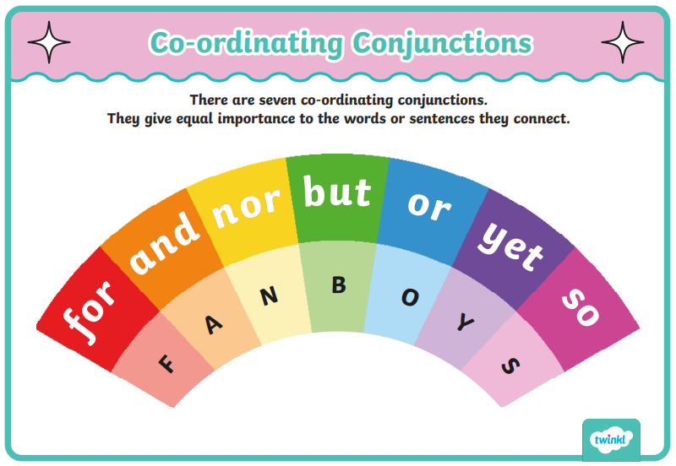
Some sentences containing coordinating conjunctions have been written below. Can you mark my work by checking each sentence has used the correct coordinating conjunction (it must be a FANBOYS conjunction) and that they have been punctuated and spelt correctly?
Note: None of the sentences require a comma before the coordination conjunction!
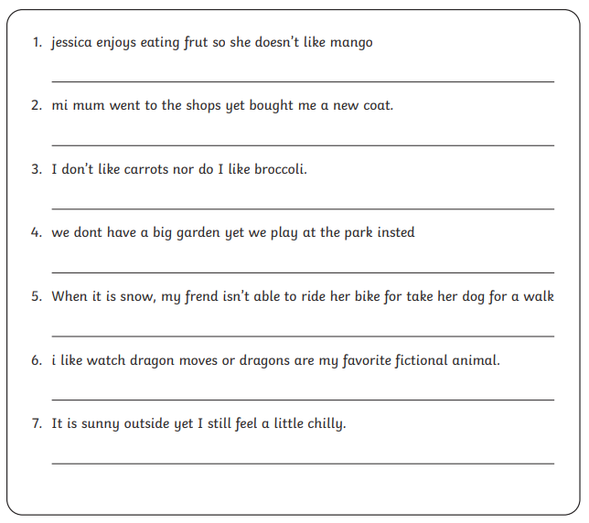
Rewrite any sentences that are incorrect on the lines provided.
Extension Task: Write some interesting sentences of your own, using a coordinating conjunction to join ideas in each one.

