Year 4 English Homework 23.1.26
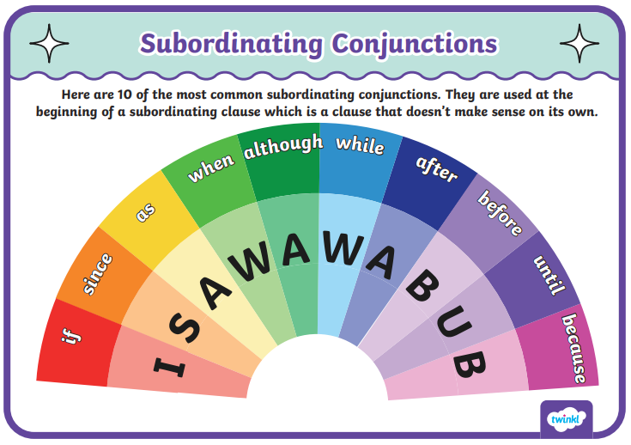
This week, we have been recognising subordinating conjunctions using the I SAW A WABUB acronym. We then looked at how these subordinating conjunctions can be used to write subordinate clauses. Subordinate clauses are a group of words that add extra information to a sentence but cannot stand alone because it doesn't make sense on its own.
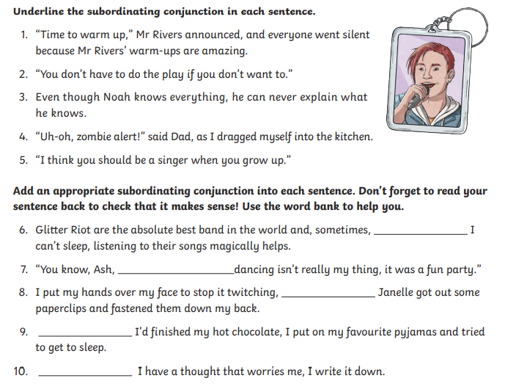
Complete the activities below to recap what you learned about subordinating conjunctions and subordinate clauses.
Extension Task: Write one or two interesting sentences of your own, using a subordinate clause (which begins with a subordinating conjunction).
________________________________________________________________________________________________________________________________________________________________________________________________________________________________________________________________________________________________________________________

