Essential Letters and Sounds (ELS) is our chosen phonics programme. It is a systematic synthetic phonics programme validated by the Department for Education in June 2021. The aim of ELS is to get all children to read well, quickly. It teaches children to read by identifying the phonemes (the smallest unit of sound) and graphemes (the written version of the sound) within words and using these to read words.
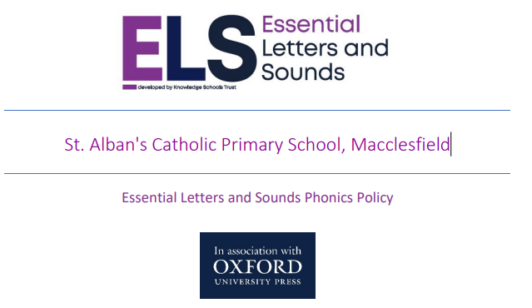
INTENT
Rationale: Phonics is a key skill that supports the development of early reading skills. At St. Alban’s, we combine quality phonic teaching and the promotion of reading for pleasure to provide our pupils with the skills they need to have a successful start to their lives as readers.
Ambition: Using the DFE validated scheme Essential Letters and Sounds (ELS), we intend our pupils to be able to:
• Recognise, say and write all phonemes within each phase of Essential Letters and Sounds
• Use their phonic knowledge to blend and segment phonetically decodable words
• Use their phonic knowledge to attempt to read and write more complex words
• Read Harder to Read and Write words
• Write clearly, accurately and coherently, using their phonic knowledge
IMPLEMENTATION
In order to implement our intent, we have:
• A DFE validated scheme of work that teaches specific, relevant and ambitious vocabulary (Essential Letters and Sounds)
• A cohesive and consistent approach to teaching phonics, where daily sessions follow the same structure
• Ensured that staff are equipped with the necessary professional development to deliver our curriculum
• Daily Phonics sessions in Early Years, Key Stage 1 and for some KS2 children. Ensuring the children learn the 44 phonemes of the English language
• A progressive scheme of work where the teaching of phonics begins in Reception and progresses with the children at a sustained pace.
• Children improve their ability to segment and blend sounds, and their ability to apply this knowledge into their reading and writing
• Small and focussed group teaching to target children’s specific next steps
• An assessment system that informs teaching
• Use appropriate ELS interventions to ensure children Keep Rather Than Catch Up
• Regular reading opportunities and story times for all children in school
• A Phonics Screening Check for Year 1 in the summer term and for those in Year 2 who need to resit
• An Early Reading Team who monitor teaching and learning to improve standards and outcomes
• A curriculum that meets the needs of all pupils (including SEND)
IMPACT
Through implementing the above:
• Pupils will be confident in their phonic knowledge
• Pupils will be able to blend and segment words confidently
• Pupils will pass the Phonics Screening Check
• A culture where a secure knowledge of phonic sounds enables reading for pleasure as part of our reading curriculum.
Reading and decodable texts
Reading is at the heart of everything that we do. Reading is a central part of every pupil’s life at our school. We instil a love of reading from the very beginning of their education, every child at our school is a reader and so are their teachers. We believe all children can become confident readers during their time in primary education.
Children’s love for reading is evident through their continuous engagement, desire to read for pleasure and their understanding of a range of texts, authors and illustrators.
To ensure all children learn to read well, quickly, children learn Phonics from the very start of Reception. It is explicitly taught every day during a dedicated slot on the timetable. Throughout the day, children use their growing Phonic knowledge to support them in other areas of the curriculum and have many opportunities to practise reading decodable texts precisely matched to the phonic knowledge. This includes reading 1:1 with a member of staff, small group guided reading sessions and during whole class reading sessions. We know that reading is a fundamental life skill and ensure that all children leave our school able to read well.
ELS is supported by a wide range of decodable texts. These cover both fiction and nonfiction and are exciting and engaging for all our pupils. We match the home reading texts to each child’s current phonic knowledge to ensure that they consolidate their most recent teaching and learning at home. Children experience the joy of books and language whilst rapidly acquiring the skills they need to become fluent independent readers and writers. ELS teaches relevant, useful and ambitious vocabulary to support children’s journey to becoming fluent and independent readers.
Key Features of the Teaching of Phonics:
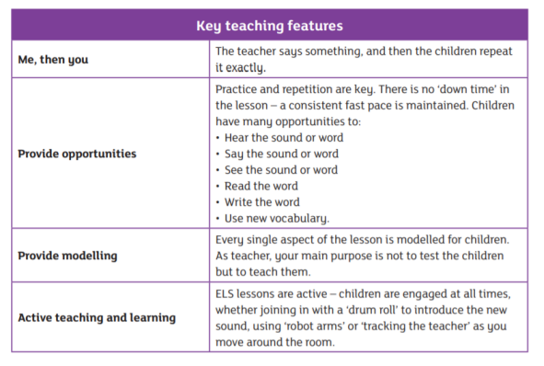
Writing
We reinforce the link between reading and writing in every ELS lesson through the independent application of the children’s understanding. We also ensure that all our teachers reference the learning from ELS lessons when writing as part of the wider curriculum.
Letter formation:
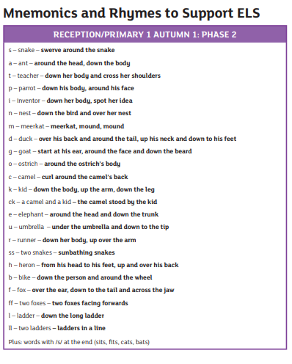
Spelling sequence:
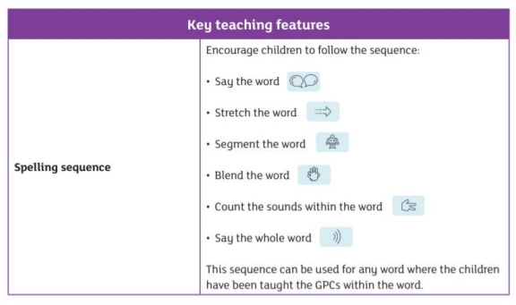
Keep up, not catch up
ELS is a whole class teaching model. This means that every single pupil has the same opportunities when learning to read. Learning to read well, early, is a priority for every child. Children who may find it harder to learn how to read are given extra support from their teacher. Daily Phonics lessons continue in Year 1 and further through the school to ensure all children become confident, fluent readers.
ELS is designed on the principle that children should ‘keep up’ rather than ‘catch up’. Interventions are delivered within the lesson by the teacher and any child who is struggling with the new knowledge can be immediately targeted with appropriate support. Where further support is required, 1:1 intervention is used where needed. These interventions are short, specific and effective. ELS is designed to make use of all the teaching time during the phonics lesson – through targeted support where required, reducing the need for external interventions - meaning that there is minimal disruption to curriculum teaching time. Where further phonic support is required in Key Stage 2, this is timetabled daily to ensure that any child rapidly catches up. Children are assessed in week 5 of each half term to ensure that any specific gaps can be targeted immediately.
CPD
All members of staff are trained to teach ELS to ensure that we have an expert team of reading teachers led by our Early Reading Team. As a staff team, we regularly meet to review our practice and to practise teaching together. This ensures that all children receive high-quality first teaching every day. Our classrooms are well resourced to ensure that every child has the resources required to learn to read well
Progression and Sequencing
We follow the ELS progression and sequence. This allows our children to practise their existing phonic knowledge whilst building their understanding of the ‘code’ of our language. As a result, children can tackle any unfamiliar words that they might discover.
We teach children more rarely used GPCs through the ELS progression. This means that they can decode and read more words with increased fluency.


