St. Alban’s Catholic Primary School

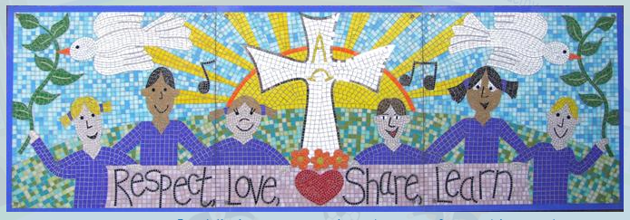

Reading in
Key Stage 1

The Curriculum
In Key Stage 1 we build upon the rigorous programme of synthetic phonics taught in EYFS and continue to focus upon the key skills of comprehension, fluency and word reading as well as promoting a love of books.
National Curriculum
During year 1, teachers should build on work from the EYFS, making sure that pupils can sound and blend unfamiliar printed words quickly and accurately using the phonic knowledge and skills that they have already learnt. Teachers should also ensure that pupils continue to learn new grapheme-phoneme correspondences (GPCs) and revise and consolidate those learnt earlier. The understanding that the letter(s) on the page represent the sounds in spoken words should underpin pupils’ reading and spelling of all words. This includes common words containing unusual GPCs. The term ‘common exception words’ is used throughout the programmes of study for such words.
Alongside this knowledge of GPCs, pupils need to develop the skill of blending the sounds into words for reading and establish the habit of applying this skill whenever they encounter new words. This will be supported by practice in reading books consistent with their developing phonic knowledge and skill and their knowledge of common exception words. At the same time, they will need to hear, share and discuss a wide range of high-quality books to develop a love of reading and broaden their vocabulary.
Pupils should be helped to read words without overt sounding and blending after a few encounters. Those who are slow to develop this skill should have extra practice.
Year 1 Reading - word reading
Pupils should be taught to:
- apply phonic knowledge and skills as the route to decode words
- respond speedily with the correct sound to graphemes (letters or groups of letters) for all 40+ phonemes, including, where applicable, alternative sounds for graphemes
- read accurately by blending sounds in unfamiliar words containing GPCs that have been taught
- read common exception words, noting unusual correspondences between spelling and sound and where these occur in the word
- read words containing taught GPCs and –s, –es, –ing, –ed, –er and –est endings
- read other words of more than one syllable that contain taught GPCs
- read words with contractions [for example, I’m, I’ll, we’ll], and understand that the apostrophe represents the omitted letter(s)
- read books aloud, accurately, that are consistent with their developing phonic knowledge and that do not require them to use other strategies to work out words
- reread these books to build up their fluency and confidence in word reading

Reading - comprehension
Pupils should be taught to:
- develop pleasure in reading, motivation to read, vocabulary and understanding by:
  - listening to and discussing a wide range of poems, stories and non-fiction at a level beyond that at which they can read independently
  - being encouraged to link what they read or hear to their own experiences
  - becoming very familiar with key stories, fairy stories and traditional tales, retelling them and considering their particular characteristics
  - recognising and joining in with predictable phrases
  - learning to appreciate rhymes and poems, and to recite some by heart
  - discussing word meanings, linking new meanings to those already known
- understand both the books they can already read accurately and fluently and those they listen to by:
  - drawing on what they already know or on background information and vocabulary provided by the teacher
  - checking that the text makes sense to them as they read, and correcting inaccurate reading
  - discussing the significance of the title and events
  - making inferences on the basis of what is being said and done
  - predicting what might happen on the basis of what has been read so far
- participate in discussion about what is read to them, taking turns and listening to what others say
- explain clearly their understanding of what is read to them

Year 2
By the beginning of year 2, pupils should be able to read all common graphemes. They should be able to read unfamiliar words containing these graphemes, accurately and without undue hesitation, by sounding them out in books that are matched closely to each pupil’s level of word-reading knowledge. They should also be able to read many common words containing GPCs taught so far [for example, shout, hand, stop, or dream], without needing to blend the sounds out loud first. Pupils’ reading of common exception words [for example, you, could, many, or people], should be secure. Pupils will increase their fluency by being able to read these words easily and automatically. Finally, pupils should be able to retell some familiar stories that have been read to and discussed with them or that they have acted out during year 1.
During year 2, teachers should continue to focus on establishing pupils’ accurate and speedy word-reading skills. They should also make sure that pupils listen to and discuss a wide range of stories, poems, plays and information books; this should include whole books. The sooner that pupils can read well and do so frequently, the sooner they will be able to increase their vocabulary, comprehension and their knowledge across the wider curriculum.
Reading - word reading
Pupils should be taught to:
- continue to apply phonic knowledge and skills as the route to decode words until automatic decoding has become embedded and reading is fluent
- read accurately by blending the sounds in words that contain the graphemes taught so far, especially recognising alternative sounds for graphemes
- read accurately words of two or more syllables that contain the same graphemes as above
- read words containing common suffixes
- read further common exception words, noting unusual correspondences between spelling and sound and where these occur in the word
- read most words quickly and accurately, without overt sounding and blending, when they have been frequently encountered
- read aloud books closely matched to their improving phonic knowledge, sounding out unfamiliar words accurately, automatically and without undue hesitation
- reread these books to build up their fluency and confidence in word reading
Reading - comprehension
Pupils should be taught to:
develop pleasure in reading, motivation to read, vocabulary and understanding by:
listening to, discussing and expressing views about a wide range of contemporary and classic poetry, stories and non-fiction at a level beyond that at which they can read independently
discussing the sequence of events in books and how items of information are related
becoming increasingly familiar with and retelling a wider range of stories, fairy stories and traditional tales
being introduced to non-fiction books that are structured in different ways
recognising simple recurring literary language in stories and poetry
discussing and clarifying the meanings of words, linking new meanings to known vocabulary
discussing their favourite words and phrases
continuing to build up a repertoire of poems learnt by heart, appreciating these and reciting some, with appropriate intonation to make the meaning clear
understand both the books that they can already read accurately and fluently and those that they listen to by:
drawing on what they already know or on background information and vocabulary provided by the teacher
checking that the text makes sense to them as they read, and correcting inaccurate reading
making inferences on the basis of what is being said and done
answering and asking questions
predicting what might happen on the basis of what has been read so far
participate in discussion about books, poems and other works that are read to them and those that they can read for themselves, taking turns and listening to what others say
explain and discuss their understanding of books, poems and other material, both those that they listen to and those that they read for themselves

Phonics Lessons in KS1
At St. Alban’s, we teach children to read using the Essential Letters and Sounds programme. It is a highly regarded synthetic phonics programmed to teach our children to read accurately and with fluency. The programme is designed for children aged 4 – 7, with the aim that all children are confident readers in Year 2. However, the children continue the programme beyond the age of 7 if they they need extra support with their reading.

How children learn to read
All children in KS1 have daily phonics lessons which last for 30 minutes.
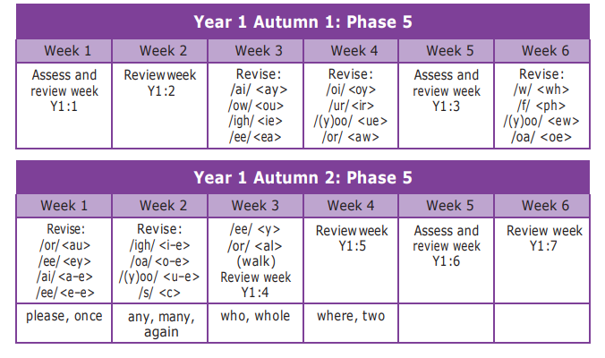
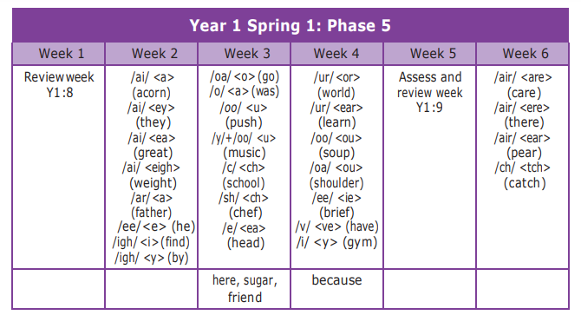
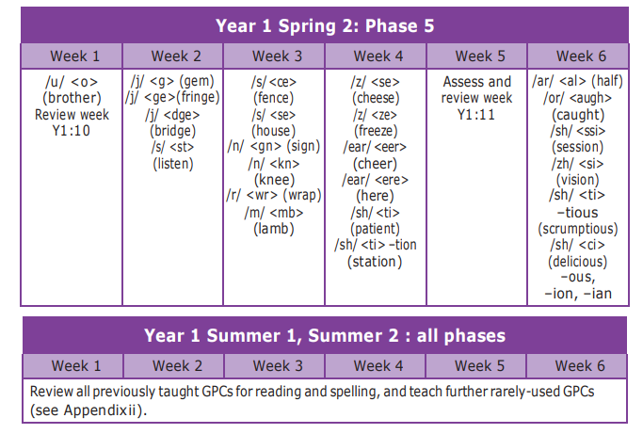
Year 1 Summer 2 and beyond
• With ELS, phonics teaching does not stop at the end of Year 1, but continues as children move through the school, with links being made between their GPC knowledge and spelling
• Revision of all previously taught GPCs for reading and spelling
• Wider reading, spelling and writing curriculum

Guided Reading
Guided reading takes place in small groups every day. Children work with the teacher or teaching assistant to apply the skills they have learnt in phonics to read phonetically decodable books. Comprehension skills are also embedded during these sessions.
We strongly value the contribution parents and carers make in helping their child learn to read. We believe it is important that approaches used at home mirror how the children are taught to read in school. Therefore, the guided text is sent home for children to continue to practise reading with their families. We recommend that the children read the text three times so that fluency and expression can be developed. Comments in each child’s guided reading log allow for feedback on these sessions.
In addition, the children take home a free choice book to share with their families which may be above their reading ability but which is chosen to promote reading for pleasure.
While the teacher is reading with a group, the rest of the children complete written activities, read for pleasure or answer comprehension questions.

Shared Reading
Our classes have a class book which is read to them daily. The stories chosen are at a higher reading level to give the children the opportunity to listen and imagine. It is essential that children have the opportunity to hear texts modelled and enjoyed by adults. It also helps them to develop their active listening skills.
We also encourage the children to read across the curriculum by ensuring we provide a range of texts on our topics. Many of our curriculum powerpoints are also designed to be read by the children.
Each classroom has wide range of books for our children to choose from. These books are to encourage reading for pleasure and parents are encouraged to read the book to their child whilst involving their child in the text.

Phonics Screening Check
Children in Year 1 take the phonics screening check in the summer term. The check is administered by a teacher and the children complete this individually. It is made up of 40 decodable words which the children read; 20 words are real words and 20 words are nonsense/alien words.
The check tests the following:
- a pupil’s ability to sound out and blend graphemes in order to read simple words
- ability to read phonetically decodable one-syllable and two-syllable words e.g. cat, windmill
- ability to read a selection of nonsense words which are referred to as pseudo words

Assessment
- Termly phonics assessments completed on a 1:1 basis to gauge how reading is progressing and which graphemes need more work on.
- Formative assessment and questioning throughout guided reading sessions (small group discussion).
- Phonics screening check (1 :1 basis in June).
- Dialogue with parents via reading log books – opportunity for parents to comment on progresses/challenges.

