St. Alban’s Catholic Primary School

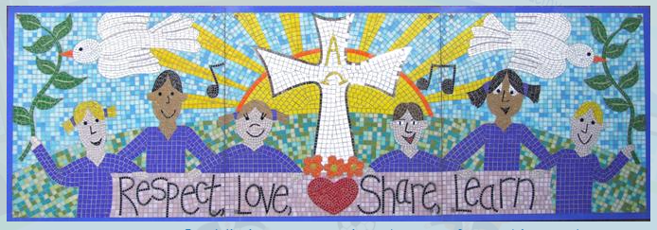

Reading in the
EYFS

The Curriculum
The EYFS Statutory Educational Programme for Literacy:
It is crucial for children to develop a life-long love of reading. Reading consists of two dimensions: language comprehension and word reading. Language comprehension (necessary for both reading and writing) starts from birth. It only develops when adults talk with children about the world around them and the books (stories and non-fiction) they read with them, and enjoy rhymes, poems and songs together. Skilled word reading, taught later, involves both the speedy working out of the pronunciation of unfamiliar printed words (decoding) and the speedy recognition of familiar printed words.

Development Matters Curriculum Guidance for Reading
Children in reception will be learning to:
- Read individual letters by saying the sounds for them.
- Blend sounds into words, so that they can read short words made up of known letter– sound correspondences.
- Read some letter groups that each represent one sound and say sounds for them.
- Read a few common exception words matched to the school’s phonic programme.
- Read simple phrases and sentences made up of words with known letter–sound correspondences and, where necessary, a few exception words.
- Re-read these books to build up their confidence in word reading, their fluency and their understanding and enjoyment.

Early Learning Goal – Word Reading
Children at the expected level of development will:
- Say a sound for each letter in the alphabet and at least 10 digraphs;
- Read words consistent with their phonic knowledge by sound-blending;
- Read aloud simple sentences and books that are consistent with their phonic knowledge, including some common exception words.
Early Learning Goal – Comprehension
Children at the expected level of development will:
- Demonstrate understanding of what has been read to them by retelling stories and narratives using their own words and recently introduced vocabulary;
- Anticipate – where appropriate – key events in stories;
- Use and understand recently introduced vocabulary during discussions about stories, non-fiction, rhymes and poems and during role-play.

Essential Letters and Sounds
Essential Letters and Sounds (ELS) is our chosen phonics scheme. It is a systematic synthetic phonics programme validated by the Department for Education. The aim of ELS is to get all children to read well, quickly. It teaches children to read by identifying the phonemes (the smallest unit of sound) and graphemes (the written version of the sound) within words and using these to read words.
To ensure all children learn to read well, quickly, children learn Phonics from the very start of Reception. It is explicitly taught every day during a dedicated slot on the timetable.

Methods to teach phonics
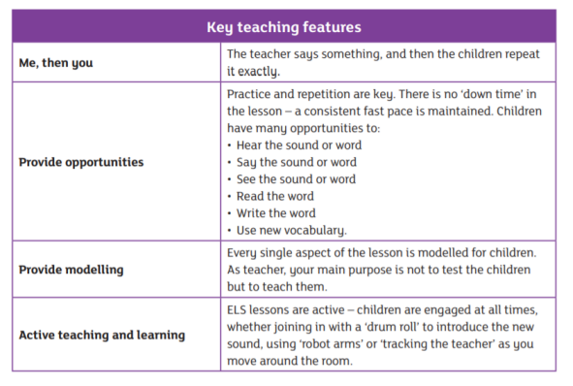

Progression

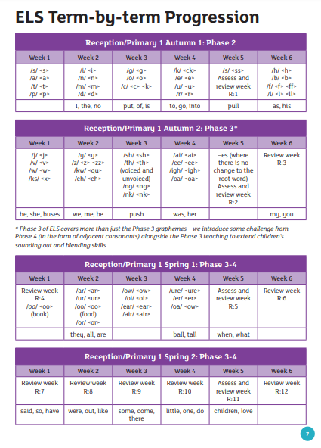
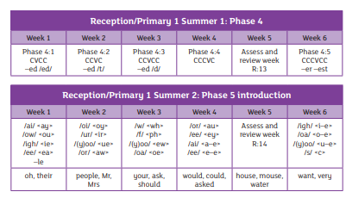

Assessment
In Week 5 of every half-term, children are assessed on their phonic knowledge using Phonics Tracker. Assessment of the children’s reading skills is key to ensuring that all children make rapid progress though the programme.
The assessment information informs teachers where there are sound and grapheme gaps, and difficulties with blending and decoding, and this enables teachers to identify the appropriate interventions.

Guided Reading
Guided Reading takes place in small groups each day. Children apply the skills they have learnt in phonics to read phonetically decodable books.
ELS is supported by a wide range of decodable texts. These cover both fiction and non-fiction and are exciting and engaging for all our pupils. We match the texts to each child’s current phonic knowledge to ensure that they consolidate their most recent teaching and learning.
The guided reading text is then sent home for children to continue to practise reading with their families. Comments in each child’s guided reading log gives guidance to parents on how to support their children’s reading at home.
Partnership with Parents
We hold a curriculum information evening in the autumn term of the Reception year. Within this meeting, we show parents the methods we use to teach phonics in school and explain how they can support their child to learn to read at home. In addition to the guided reading books, we send home phonics homework each week. This keeps parents informed of the Grapheme-Phoneme correspondences their child has learnt that week and gives the children the opportunity to practise and apply their growing phonic knowledge.

How we develop a culture of reading in Reception
We understand the richness that stories and books can bring to a children’s imagination. We place high value on our daily story times and book-led learning inputs, as they can inspire an understanding of the world in our children that may otherwise be beyond their reach at that moment in time.
To develop a culture of reading we ensure that our Reception curriculum is book led. We give high priority to the following:
- A daily designated slot for story time
- A voting station so that every child gets to vote on the book they would like to hear at story time
- Reading Areas – in the heart of the classroom and on both carpeted areas
- Books in continuous provision e.g. Art and Craft books in our craft area
- Regular new books from the Education Library Service
- Daily visits from our Year 6 Reading Ambassadors
- Book theme days
- A Macclesfield Library visit so that each Reception child is signed up to receive a library card, providing them with lifetime access to thousands of books and services.
- Talk for Writing – provocations to generate children’s interest, story maps and actions to support understanding of the story, imitation, innovation and retelling
- Helicopter Storytelling
- Home Corner – supporting children to act out narratives using props e.g. The Three Bears Cottage, and Town Mouse, Country Mouse stories.

