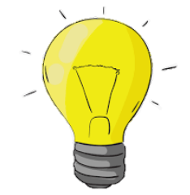
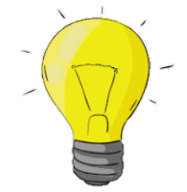
KNOWLEDGE ORGANISER
Let It Shine!
Y6

Our eyes have a small window at the front called a pupil, through which light can enter. The pupil looks as though it is black because it is dark inside our eyes.
What you should already know… |  |  | How Light Travels
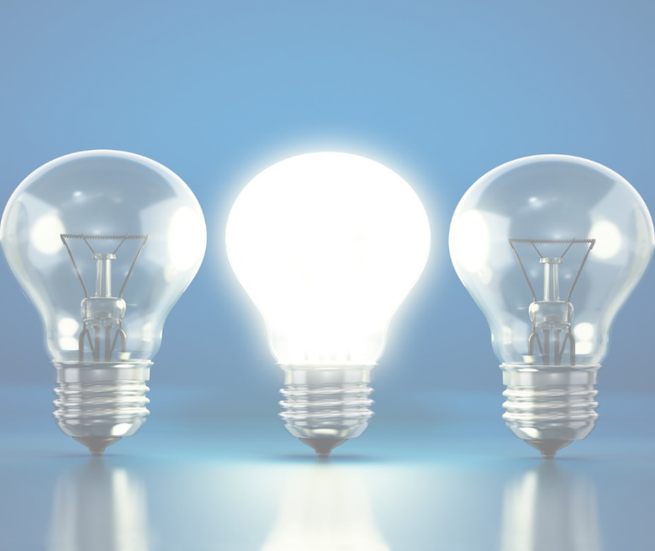  -Light is a form of energy that makes it possible to see.  Light is given off some objects (for example the Sun). Darkness is the absence of light.  -Light can reflect off surfaces (e.g. mirrors). Light is absorbed by other materials.  -Objects can be labelled as transparent, translucent, or opaque, depending on the amount of light that they let through.  -Shadows are formed when light is blocked by an opaque object. |  |  |  | 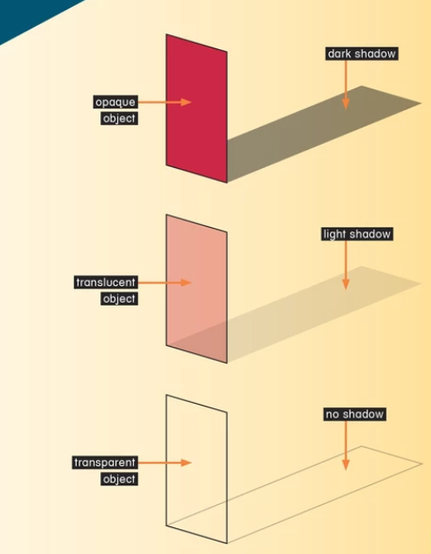 | -Light originates from light sources.  -Light sources can be natural (e.g. The Sun, the stars) or man-made (e.g. street lamp, Christmas tree lights, glow stick, mobile phone, TV).  -Light travels in a straight line from light sources.  -We can see that light travels in straight lines when we shine a torch in a dark room, or when a ray of light comes through a window.  -When an object passes in front of a ray of light, the light can be blocked, creating a shadow.  -Opaque objects let no light through (creating the darkest shadows), translucent objects let some light through (creating fainter shadows), transparent objects let all light through (no shadow).
How We See Things
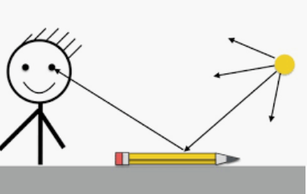
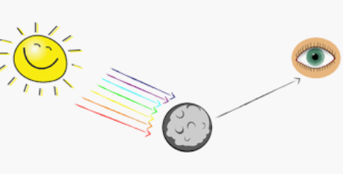
-We see things because…
a.) they are a light source, sending light into our eyes, or
b.) light is reflected from a light source off them and into our eyes.
When the light enters our eyes, we see the object!
-For example, we see The Sun because it is a light source, sending light into our eyes.
-However, The Moon is not luminous (does not produce its own light). We see it because light from The Sun reflects off it into our eyes.
- After light reflects off objects, it continues to travel in a straight line, but in a new direction.

 |  |  | Our Eyes
 |  |  |  | 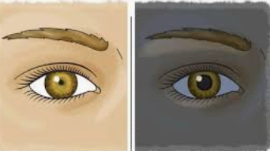 | -When it is dark, our pupils go larger, in order to let more light in so that we can see better. In bright lights, our pupils go smaller.  -At the back of our eye is a sensitive sheet of nerves called a retina. They can detect light when it comes in through the pupil, and send messages to the brain about what we can see.

Light Spectrum
Green
Indigo
Blue
Yellow
Orange
Violet
Red

