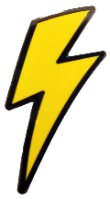
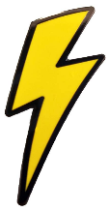
Electrifing
KNOWLEDGE ORGANISER
Y6

What you should already know… |  |  | Electricity Safety
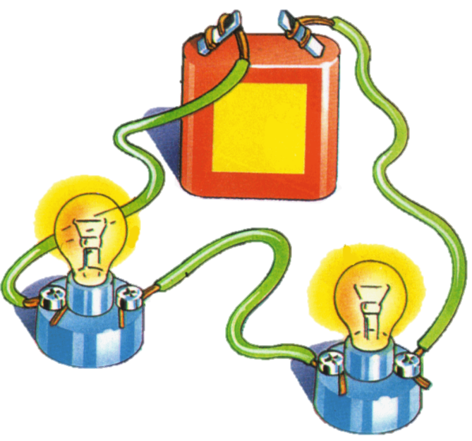  -Electricity is a type of energy.  -It is used to power lots of different things, including many items that we use in everyday life.  -Electricity can flow through wires and cables, and can be stored in batteries (sometimes called cells).  -Electricity can flow in simple series electrical circuits.  -Some materials conduct electricity, and others do not (insulators). |  |  |  | 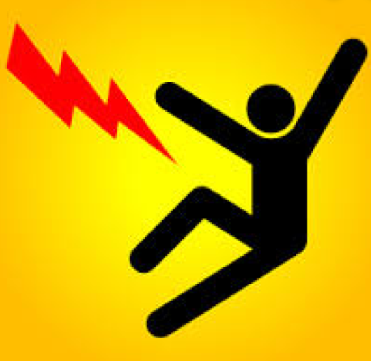 | If electricity is not used safely, it can be highly dangerous. When using electricity, make sure that you:  -Make sure that wires are placed in safe locations, where people cannot trip over them;  -Never stick your fingers or objects into a plug socket;  -Never use frayed wires – don’t pull wires;  -Ensure that your hands are dry when you are near sockets/ electrical equipment;  -Do not overload a plug socket;  -Always get broken appliances and plugs fixed.
Circuit Diagrams |  |  | Variation of Components
When drawing electrical circuits, you should use the standard symbols to show the different components.  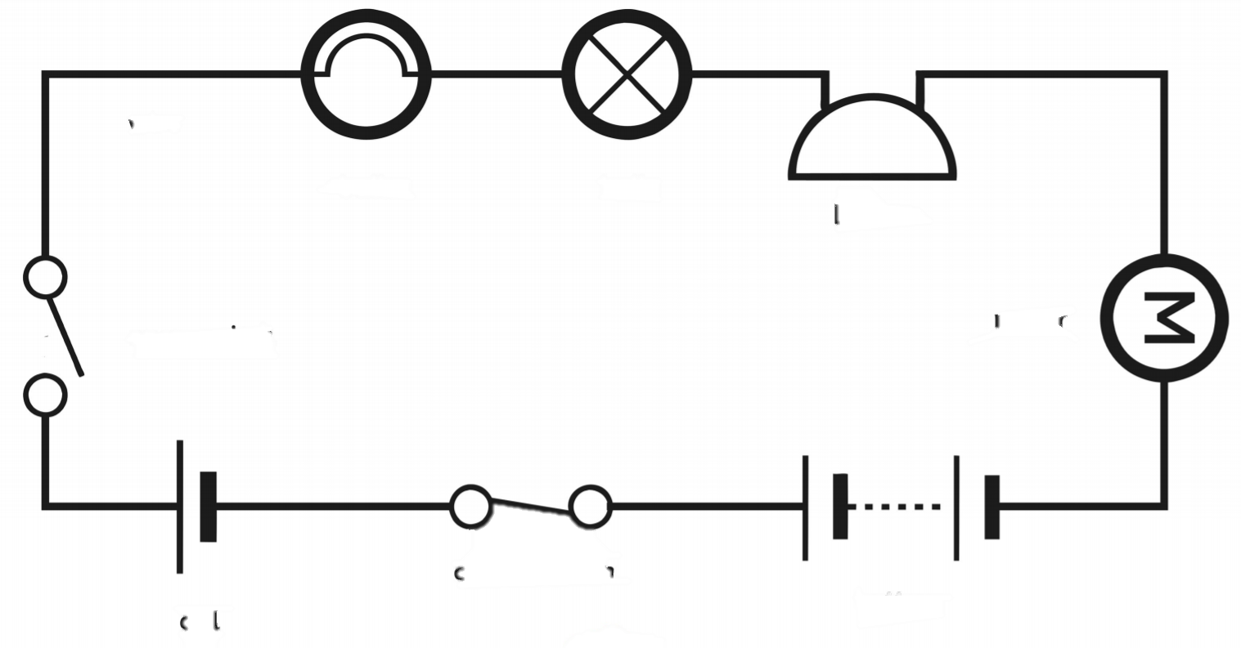  Bulb (Lighting)  Bulb (Indicator)  Buzzer  Motor  Battery  Cell  Switch (Closed)  Switch (Open) |  |  | 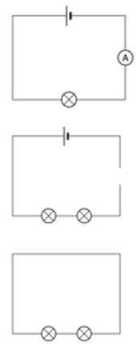  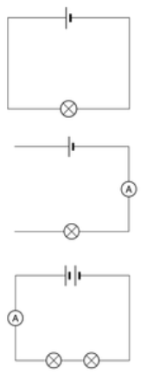  When changes are made to circuits, components can function differently:  -When switches are open or wires are removed from a circuit (so that it is no longer a closed circuit), bulbs and buzzers will turn off. You can use crocodile clips to investigate adding and removing wires.  -When more batteries or cells are added (or batteries or cells are included with a higher voltage) the brightness of bulbs and the volume of buzzers will increase.  -When more bulbs are added to a simple circuit, they will be dimmer than if there were one bulb. This is because the electricity is shared between the two bulbs. More voltage would be needed to make them brighter.  You should be able to look at circuits like those on the left, and work out what would happen.
Key Electrical Vocabulary
Voltmeter
Cell
Buzzer
Wire
Ammeter
Battery
Motor
Voltage
Bulb
Switch

