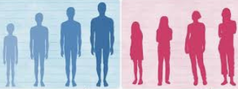
Growing up and Growing Old
Y5
KNOWLEDGE ORGANISER

What you should already know… |  |  | Ageing to Old Age
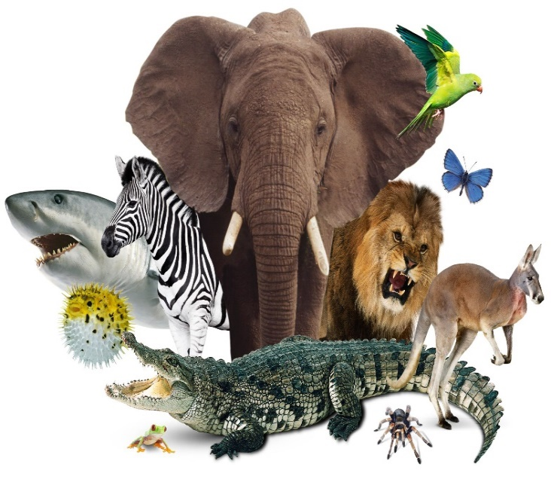  -Food chains are used to show how living things get their food.  -Food chains are made up of producers (who produce their own food) and consumers (animals who eat producers and other consumers).  -Humans have incisor, canine, pre-molar and molar teeth, each with different jobs. Animals have different make-ups of teeth depending on their food.  -The digestive system has several functions, including ingestion, absorption and excretion. It is made up of different parts, e.g. the stomach. |  |  |  | 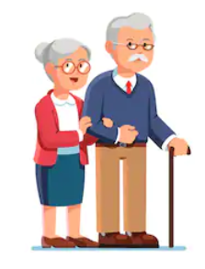 |  | -Muscle mass decreases and muscles lose strength.  -Wrinkles develop on the skin, and it loses its elasticity.  -Hair begins to turn grey/ white. Many people begin to lose the hair on their heads (mainly men).  -Fertility decreases (more quickly for women).  -People begin to shrink in height as bones and cartilage become worn down.  -Organs begin to lose their effectiveness, and the senses (e.g. sight, hearing, etc.) become weaker.
Puberty |  |  | Growth and Development of Animals
What is puberty?  -Puberty is when a child’s body begins to grow, change and develop as they become an adult.  -In humans, puberty normally begins around age 11-12, however it can take place anytime from age 8-14. Puberty happens when the pituitary glands begin to release hormones. |  |  | Humans |  | House Mice |  | African Elephants | Saltwater Crocodiles |  | Blue Whales
 |  |  | Gestation Period:  9 months  Sexual Maturity:  11-17 years  Life Expectancy:  80 years   |  | Gestation Period:  20 days  Sexual Maturity:  4-6 weeks  Life Expectancy:  1 year  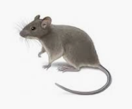 |  | Gestation Period:  22 months  Sexual Maturity:  10-12 years  Life Expectancy:  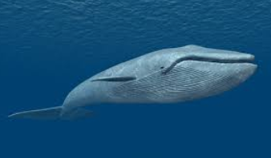  60 years  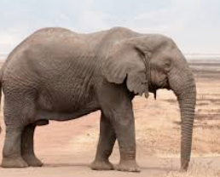 | Gestation Period:  2-3 months  Sexual Maturity:  10-12 years  Life Expectancy:  70 years   |  | Gestation Period:  10-12 months  Sexual Maturity:  10 years  Life Expectancy:  90 years
Males  -Boys grow taller. They develop more muscle mass, and their chest and shoulders broaden.  -Boys’ voices become deeper. Their skin becomes oilier, meaning they may get spots.  -Hair begins to grow on their faces and bodies, including armpit and pubic hair.  -Penis and testicles grow larger. The testicles begin to make millions of sperm. | Females  -Girls grow taller. They develop breasts, and their hip bones widen. The body becomes curvier.  -Hair begins to grow on their bodies, including armpit and pubic hair.  -Menstruation begins. Girls begin to have periods, and their uterus (womb) begins to grow.
Human Ageing Timeline






Late Adulthood 60+ years
Mid-Adulthood 36-59 years
Early Adulthood 18-35 years
Adolescent 12-17 years
Child 2-11 years
Baby 0-1 years

