

KNOWLEDGE ORGANISER
What’s that sound?
Y4

Overview |  |  |  | How Sounds are Made
  -Sounds are made when objects vibrate.  -Vibrations travel from objects in waves to our ears, allowing us to hear sound.  -Weak vibrations make a gentle soundwave which do not travel as far as strong vibrations. This is why sounds have different volumes.  -Sounds can be high pitched or low pitched. Tight, short frequency waves make a high-pitched sound, while more loose waves make low-pitched sounds. |  |  |  | 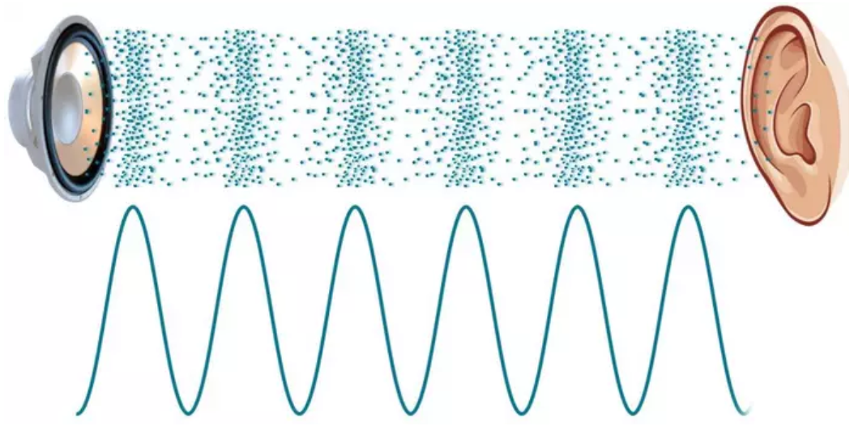 | -Sounds are created when something vibrates (shakes back and forth).  -This creates soundwaves which travel to the ears of the listener.  -When a bell is struck, the metal of the bell vibrates. These vibrations create waves in the air (sound waves).  -When they reach our ears, they make our eardrums vibrate, and we hear the sound of the bell ringing.
Pitch |  |  |  | Volume
-Pitch is the highness or lowness of sounds.  -Pitch is caused by the frequency of vibrations (how many times vibrations go back and forth per second).  -The higher the rate of vibrations, the higher the pitch.  -Lower pitch sounds have a lower rate of vibrations.  -Humans can hear a large range of pitches, high-pitch sounds e.g. a mouse squeak to low-pitch sounds e.g. the rumble of an earthquake.  -However, some sounds are too high or low-pitched for us to hear. |  | 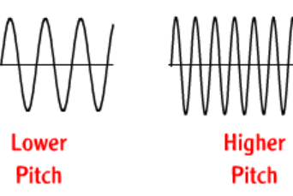   |  | 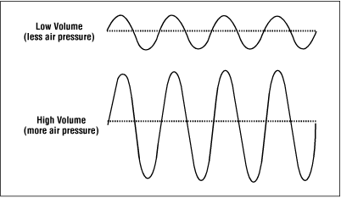  -Volume is the loudness of a sound.  -The volume of a sound depends on the amount of energy that the vibrations contain.  -Vibrations with lots of energy create large soundwaves.  -When these large soundwaves arrive at your ears, they push harder on your eardrums.  -This is why when we strike a drum harder (with more energy) it is louder than when we strike it more softly.  -Our ears can detect a wide range of loud and quiet sounds, from rumbling jet engines to leaves rustling.  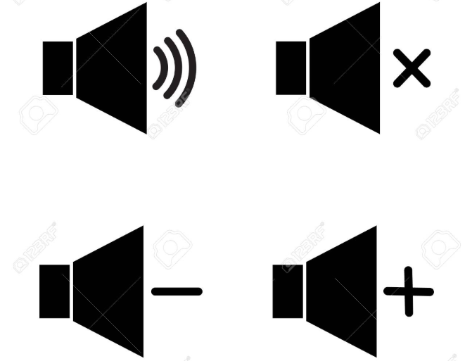
High Pitch Sounds
Low Pitch Sounds
Mouse Squeak
Shriek
Whistle
Thunder
Bass Guitar
Lion’s Roar
Child’s voice
Tuba

