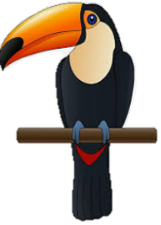
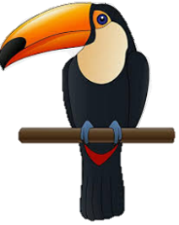
LIVING THINGS and their habitats
KNOWLEDGE ORGANISER
Y4

What you should already know… |  |  |  | Classification of Plants
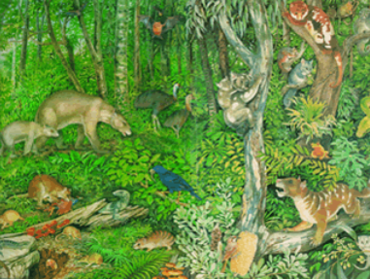  -All around us, there are some things that are alive, some things that are dead, and some things that have never been alive.  -All living things have certain characteristics that help to keep them alive and healthy.  -Living things live in habitats that suit them, and which provide for their basic needs.  -Living things depend on other living things in order to survive. |  |  |  | Flowering Plants  Flowering plants grow flowers. They use pollination in order to reproduce.  Flowering plants make up about 90% of all species of plant.  Examples of flowering plants include:  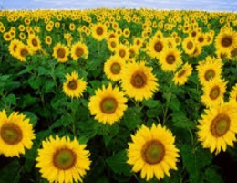  -Sunflower  -Daffodil  -Orchid  -Orange Tree  -Banana Plant | Non-Flowering Plants  Non-flowering plants do not grow flowers. They rely on seed dispersal in order to reproduce.  Non-flowering plants make up about 10% of all species of plant.  Examples of non-flowering plants include:  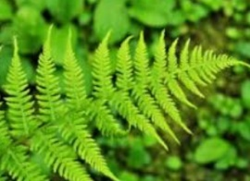  -Fern  -Moss  -Algae  -Conifer  -Seaweed
Classification of Animals |  |  |  | Habitat Changes
M-R-S G-R-E-N  You can remember the seven features of living things by using the acronym MRS GREN (Movement, Respiration, Sensitivity, Growth, Reproduction, Excretion and Nutrition. |  |  |  | 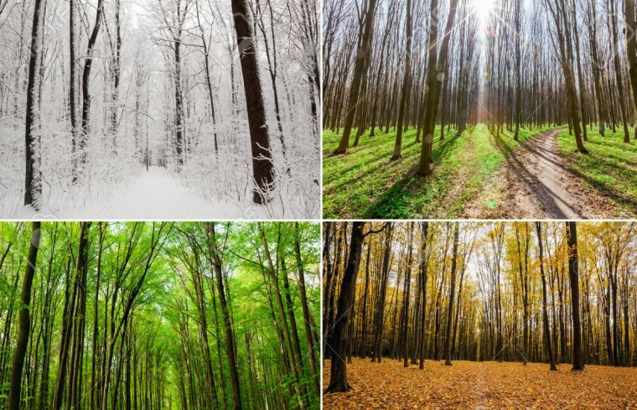  Animals are often adapted to the habitats that they live in. However, habitats can change over time, which may present animals and plant life with difficulties.  Some of these changes are natural, e.g:  -The seasons: temperatures rise in the summer and fall in winter. This means that some animals may need to migrate or hibernate.  -Increased or decreased rainfall can also impact on a habitat. Floods and droughts can dramatically impact on environments.  Other habitat changes are man-made, e.g:  -Harvesting fossil fuels, deforestation, dredging rivers, bottom trawling, urbanization, filling in wetlands and mowing fields.  -Global warming is thought to be impacting on many habitats.  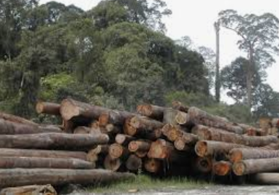
Mammals  -Mammals are warm-blooded.  -They often have hair/fur on their bodies.  -Mammals give birth to live young.  -Mammals often drink milk from their mothers. |  | Snails  -Snails have shells.  -They have a large muscular foot, which secretes mucus.  -Their stomach is directly above their muscular foot.  -Most snails live underwater.
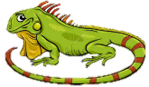  Reptiles  -Reptiles are cold-blooded.  -They normally lay eggs (but some don’t).  -Reptiles have scales or scutes. |  | Slugs  -Slugs do not have shells.  -They have a large muscular foot, which secretes mucus.  -Their stomach is directly above their muscular foot.
Amphibians  -Amphibians are cold-blooded animals.  -They have moist, scaleless skin. It is often permeable.  -Amphibians lay eggs. |  | Worms  -Worms have long, narrow bodies.  -Worms do not have limbs (arms and legs).  -They are bilaterally symmetrical (both sides the same).
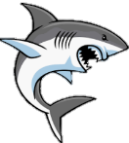  Fish  -Fish are cold-blooded animals.  -Fish can breathe underwater, using gills.  -Fish lay eggs.  -Fins help to propel fish through the water. |  | Spiders  -Spiders have eight legs.  -Spiders bodies are made of two main parts.  -Spiders create silk from their spinneret glands.  -Spiders lay eggs.
Birds  -Birds are warm-blooded.  -Birds have feathers, wings and a beak.  -Birds lay eggs. |  | Insects  -Insects have exoskeletons: hard shell-like coverings of their body. They also have three main body parts.  -They have antennae on the top of their heads.
Invertabrates – Have no backbones
Vertebrates – Have backbones
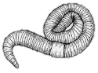
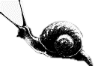
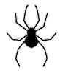
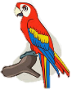
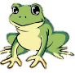
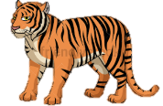
Worms
Insects
Spiders
Slugs
Snails
Mammals
Reptiles
Amphibians
Fish
Birds

