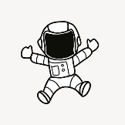
KNOWLEDGE ORGANISER
We Are Astronauts!
Y3

Overview |  |  | The moon
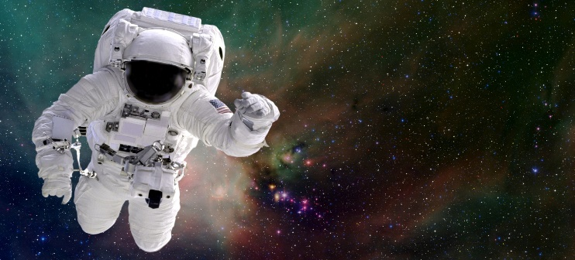  In this topic children become astronauts. First  they look at the Moon, how humans have visited it and then plan their own mission by  designing a Moon lander, making spacesuits and eating space food! |  |  |  |  | - The Earth has only one Moon.  - Our Moon is the fifth largest moon in the Solar System.  - The Moon has craters which were formed by the impact of meteorites many years ago.  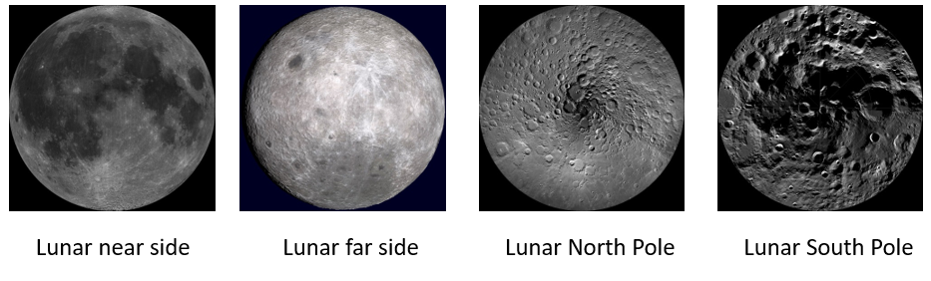  - Both sides of the Moon receive the same amount of light from the Sun.
Famous Astronauts
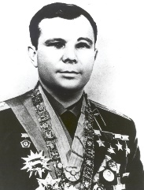  - Yuri Gagarin was the first man in space.  - Just before his space craft took off he said, “Here we go”.  - He orbited the Earth once on 12th April 1961.  - His space craft was called Vostok 1. | 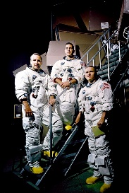  - Frank Borman, James Lovell and William Anders were the first people to orbit the Moon.  - They left the Earth on 21st December 1968.  - They took 3 days to reach the Moon and orbited 20 times.
 |  |  | Space race timeline
- Valentina Tereskovawas the first woman in space.  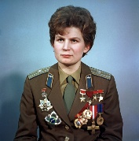  - She was Russian.  - She orbited the Earth on 16th June 1963.  - Her space craft was called Vostok 6. | - Neil Armstrong and Buzz Aldrinwere the first people to walk on the Moon.  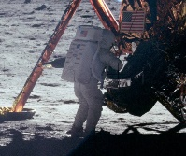  - They landed on July 20th, 1969, at 20:18  Neil said, “One small step for man, one giant leap for mankind”. |  |  |  | 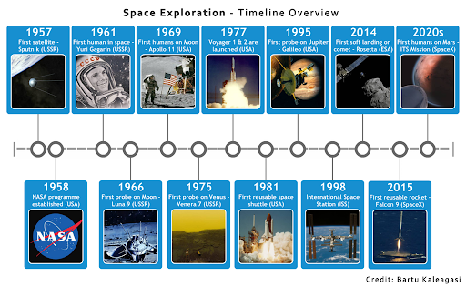

Key vocab
Astronaut Cosmonaut Taikonaut moon rocket thrust crater sphere air tight orbit space

