
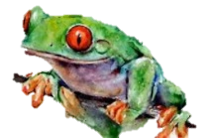
Y3
Food and our bodies
KNOWLEDGE ORGANISER

What you should already know… |  |  | Nourishment
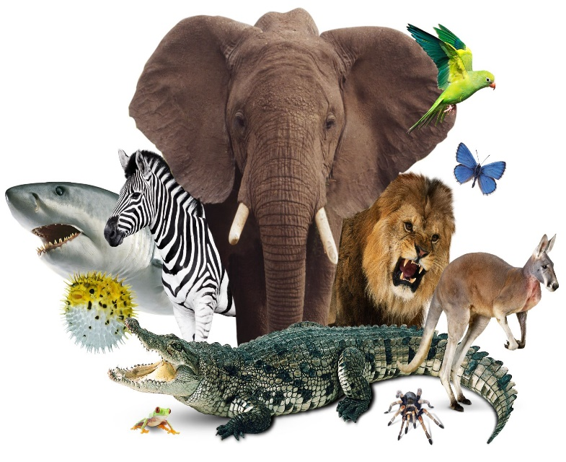  -Animals can be split into different groups (e.g. birds/fish & carnivores/omnivores)  -All animals have basic needs that have to be met in order for them to survive: water, food, shelter, oxygen, temperature  -Animals have different stages in their lives – birth, growth, reproduction and death.  -Humans (and most other animals) need to stay healthy, by exercising, eating a balanced diet, and being hygienic. |  |  | 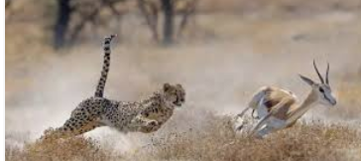 |  | -Unlike plants, animals cannot create their own food. They get nutrition from what they eat.  -This is because animals do not have chlorophyll, or chloroplasts in their cells, like plants do.  -Therefore, plants are called producers and animals are called consumers.  -The different nutrients that animals get depends on their diet. For example, a cheetah gets lots of protein in its diet because it is a carnivore (eats meat).
Types of Nutrition |  |  | Skeletons and Muscles
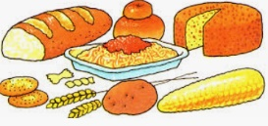  Carbohydrates  -Carbohydrates give the consumer energy.  -Foods that have lots of carbohydrates in are often called ‘starchy’ foods.  -Carbohydrate-rich foods include pasta, rice, oats, breads, breakfast cereals and barley. |  |  | 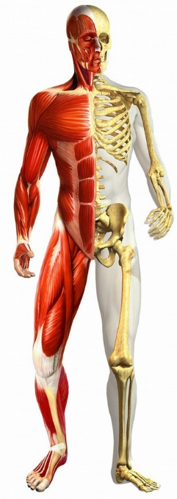  Skeleton  -Humans (and many other animals) have a system of bones called a skeleton.  -Skeletons help to support your body – they give it its shape.  -Skeletons are also important for movement. Muscles are attached to bones.  -Finally, skeletons help to protect important parts of the body. E.g. the ribs protect the heart and lungs. |  |  | Muscular System  -Humans (and many other animals) also have a system of muscles in their bodies.  -The main purpose of muscles is for movement. As they contract, muscles move parts of the body around.  -Muscles are also important for maintaining posture, helping humans/ animals to sit, stand, and walk.  -Some muscles (e.g. the heart) move by themselves – they are involuntary.
Protein  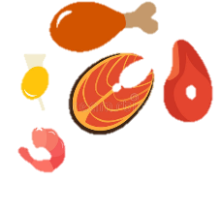  -Protein helps the body (especially the muscles) to repair itself.  -Protein-rich foods include meat, eggs & nuts. | 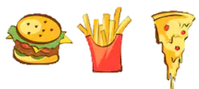  Fat  -Fats also give consumers lots of energy. However, too much fat is not healthy!  -Butter, cakes & fast food contain lots of fat.
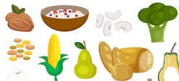  Fibre  -Fibre helps our digestive systems to work well.  -Fibre is often found in high-carboydrate foods like bread, cereal, potatoes, and some fruits. |   Vitamins and Minerals  -There are many different vitamins and minerals that perform hundreds of roles in the body.  Fruit and vegetables are vitamin/mineral-rich.
Amounts of Nutrition


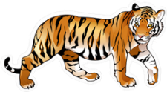
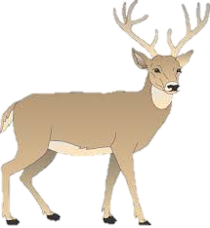
Mouse 0.004kg per day
Blue Whale 3,500kg per day
Tiger 15kg per day
Deer 4kg per day

