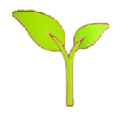
KNOWLEDGE ORGANISER
Young Gardeners
Y2

Plants have a clear life cycle that helps them to keep reproducing:
Seeds/bulbs – Plants begin life as seeds or bulbs. They need soil, air and water to grow.
Seedling – Plants grow into young plants. They now need light, temperature, water, space and time to keep growing.
Flowering/Fruit – Plants grow flowers and fruits. These produce seeds. When the plant dies or is pollinated, the seeds find their way to the soil. The process starts again!

What you should already know… |  |  | Growth from Seeds/Bulbs into Mature Plants
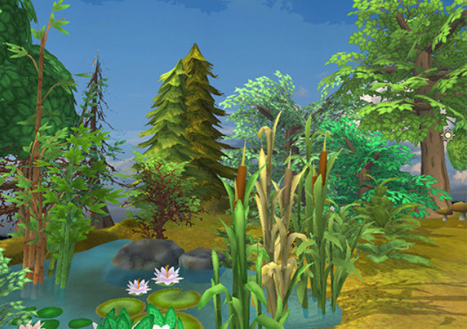  -Plants are a large group of living things that use sunlight to make their own food.  -There are many, many different kinds of plants, including trees, vines and grasses.  -Plants have lots of different parts, for example stems, leaves and roots.  -Some trees lose their leaves in the winter (deciduous). Some keep their leaves through the year (evergreen).  -Some plants are ‘flowering plants’ – they grow flowers on them. |  |  |  | 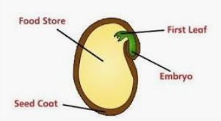 | 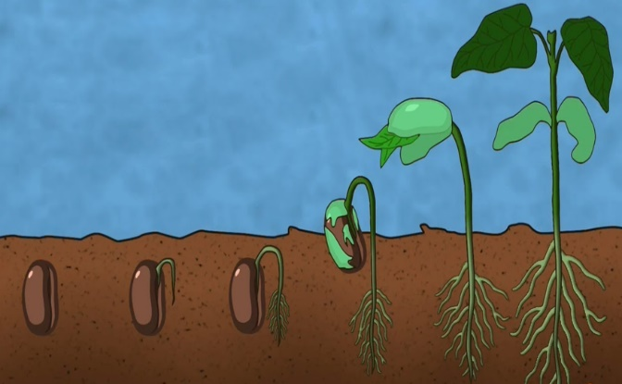  -Germination is the name for when a plant starts to grow. A plant is germinating when its seed begins to sprout.  -Inside a seed/bulb is the baby plant (an embryo). Seeds have a tough layer on the outside to protect the plant (the seed coat).  -Seeds and bulbs do not need sunlight in order to grow. They already have their own food store inside them!  -However, they do need the right conditions to grow. Normally, they need water, air and the right temperature. This can often be found in well-watered soil!
What Plants Need to Grow
  Water and Nutrients  Like animals and humans, plants need water and nutrients to survive.  -Plants are able to get water from the soil through their roots.  -They can also catch water on their leaves. |   Light  Plants need lots of sunlight to help them grow.  -Plants do not eat food. They instead use sunlight to make their own food.  -Too little light will leave plants weak.
 |  |  | Plant Life Cycle
  Temperature  -Plants need the temperature to be just right for them to grow properly.  -If it is too hot, they may burn and wilt. If it is too cold, they may freeze and die. This is why there are less plants at the poles and the deserts. |   Space and Time  -Plants need room for their roots and stems to be able to grow. Without enough room, they may not grow large enough.  -Plants also need time – it can take days, months or even years for them to grow.
 |  |  |  | 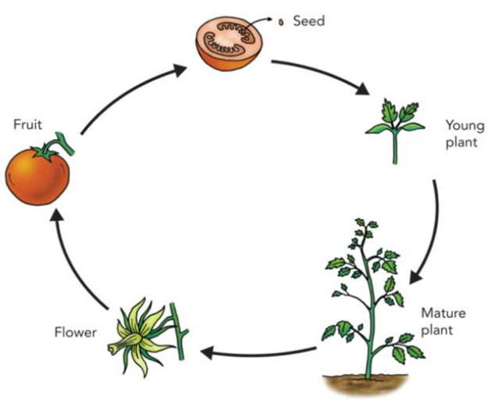

Taller Plants
Smaller Plants
Dandelion – about 25 centimetres
Dwarf Evergreen Shrub – about 1 metre
Sunflower – 1-3 metres
Titan Arum Flower – up to 3.5 metres
Spruce (Christmas Tree) – up to 30 metres
Giant Redwood Tree – 100 metres +

