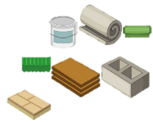
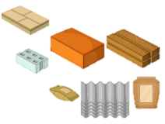
Material monster and Move it!
KNOWLEDGE ORGANISER

What you should already know… |  |  | Properties of Materials
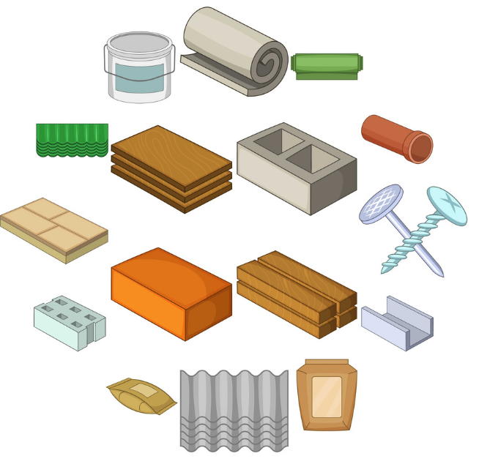  -Materials are the substances that things are made from.  -We use lots of different materials every day, e.g. metal, plastic, wood, and glass.  -Different materials have certain properties, e.g. glass is see-through, metal is strong and often shiny, etc.  -Composites are made from two or more materials together.  - Some materials are used to make many things. |  |  | Material | Image | Properties | Some Uses
 |  |  | Metal | 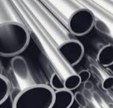 | -Metals are often strong, shiny, hard and long-lasting.  -Metals can be hammered into different shapes. | - pots and pans.  -Metals can stretched into wires and rods.
 |  |  | Glass | 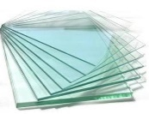 | -Glass can be strong, but thin glass shatters.  -Glass is transparent and waterproof. It can be made into different shapes. | - windows and glasses.  - mirrors, table-tops and windscreens.
 |  |  | Wood | 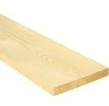 | -Wood is hard and strong;  -Wood is long-lasting and is a natural product.  -Wood is flammable. | - furniture, like benches and desks.  - houses and cabins.
 |  |  | Plastic | 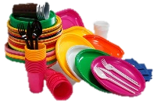 | -Plastics can be tough or flexible and can be made into any shape. Plastics can be dyed different colours and can be made transparent. | - packaging, bottles and toys.  - moulded into plates, knives and forks.
Development of Materials
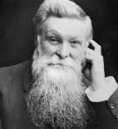
John Dunlop
-John Dunlop is famous for developing the pneumatic (air-filled) tyre.
-He did this, at first, to improve the tyres on his son’s bicycle!
-He used his understanding of rubber to fit it to a wooden disc. He then used an inflated tube of sheet rubber to blow up the tyre.
 |  |  | Rubber | 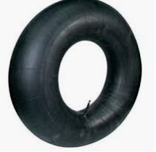 | -Rubber is extremely tough, but also very flexible.  -Rubber is elastic and also waterproof. Rubber doesn’t tear easily. | - making paints, toothpastes, shampoos and cement.
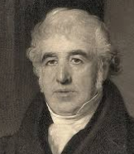  Charles Macintosh  -Charles Macintosh is best known for inventing the raincoat.  -He discovered a way in which rubber could be placed between two layers of cloth, to make it waterproof.  -His name lives on today – a raincoat is often called a Macintosh or Mac. |  |  | Brick | 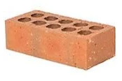 | -Bricks are very hard and strong. They are difficult to break. Bricks are thick and store heat well. | - used to make buildings.  - paving.
 |  |  | Paper | 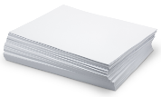 | -Paper is often thin and can be made into lots of different shapes. Paper can be torn. It goes soggy when wet. | - diaries, notebooks and for printing on.  Paper is used for posters/displays.
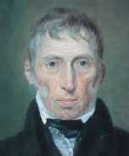
John McAdam
-John McAdam was the first person to think of tarmac roads.
-Roads used to be made from clay, earth, or chalk, but these materials were messy and not very smooth.
-He spread hot tarmac on a road, adding lime chippings & flattening.
 |  |  | Cardboard | 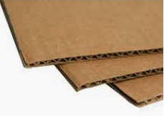 | -Cardboard is often thin but is firmer and tougher than paper. Cardboard is more difficult to tear. It goes soggy when wet. | - boxes and packaging items.
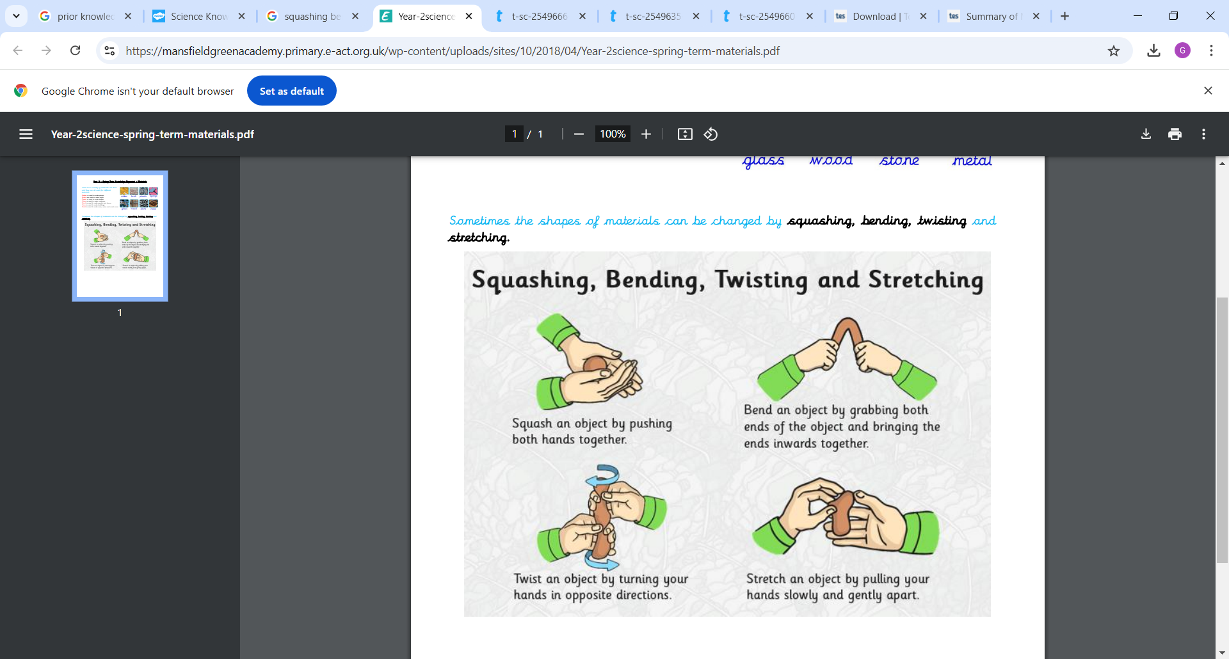
Hard smooth absorbent bumpy bouncy dull flexible translucent waterproof firm soft bendy stretchy

Firm
Soft
Waterproof
Translucent
Flammable
Flexible
Dull
Bumpy
Bouncy
Absorbent
Smooth
Squashy

