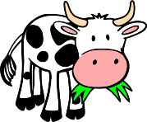
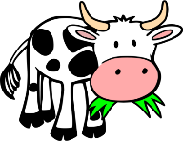
Mini World
KNOWLEDGE ORGANISER
Y2

Overview |  |  |  | Food Chains
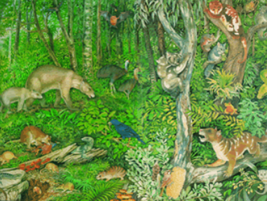  -All around us, there are some things that are alive, some things that are dead, and some things that have never been alive.  -All living things have certain characteristics that help to keep them alive and healthy.  -Living things live in habitats that suit them, and which provide for their basic needs.  -Living things depend on other living things in order to survive. |  |  |  | -Every living thing needs food in order to create energy. This process is called nutrition.  -Plants make their own food, using water, carbon dioxide and light. (Photosynthesis)  -Animals cannot make their own food. They need to eat food (either plants or other animals) in order to get energy.  -Therefore, living things depend upon one another to live. |  | 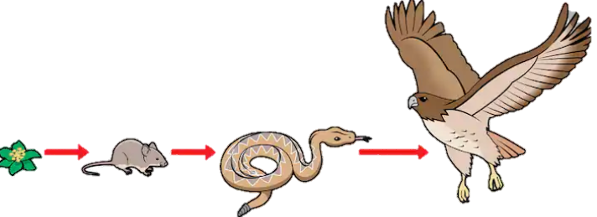
Characteristics of Living Things |  |  |  | Habitats
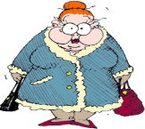  M-R-S G-R-E-N  You can remember the seven features of living things by using the acronym MRS GREN. |  |  |  | 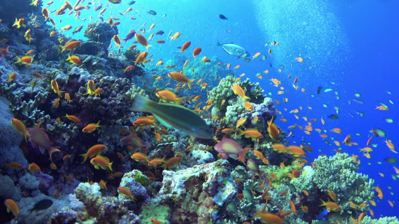  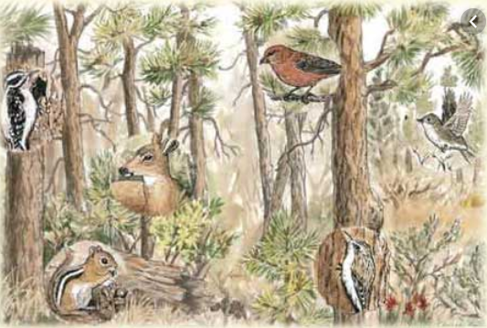  -A habitat is a home environment for plants, animals, and other living things.  -Examples of habitats include:  -Desert; Rainforest;  -Woodland; Ocean;  -Meadow; Seashore.  -Micro-habitats are small, specific home environments, e.g. individual trees, a pond, under a rock, or a pile of logs.  -Habitats contain features that make them suitable to the things that live there, e.g., food, shelter, or temperature.  -Habitats can change over the year & over time, so some animals migrate.
M | Movement | Animals move in many different ways. Plants grow and turn towards light.
R | Respiration | Plants and animals use oxygen in the air to turn food into energy.
S | Sensitivity | Living things can detect changes in their surroundings.
G | Growth | 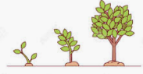  Living things get bigger and grow.
R | Reproduction | Animals have young. Plants create seeds from which new plants grow.
E | Excretion | Living things get rid of things that they make but don’t need.
N | Nutrition | 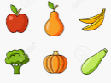  Living things need food/nutrients for energy.
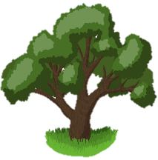
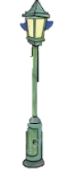
Dead
Alive
Never Been Alive

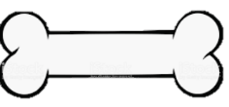
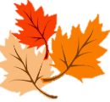
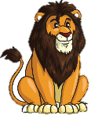
Lamp Post
Phone
Bone
Fallen Leaves
Oak Tree
Lion

