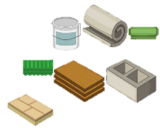
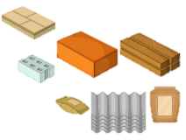
EVERYDAY MATERIALS
KNOWLEDGE ORGANISER

-A composite is a material that is made from two or more different materials.
-Composites are often made because they are stronger, lighter, or less expensive than other materials.
-For example, concrete is made out of water, cement, and either rock, sand or gravel. It is very strong.
-Fibreglass is another type of composite. It is used to make things like showers, sinks and toilets.

Overview |  |  | What are Objects Made From?
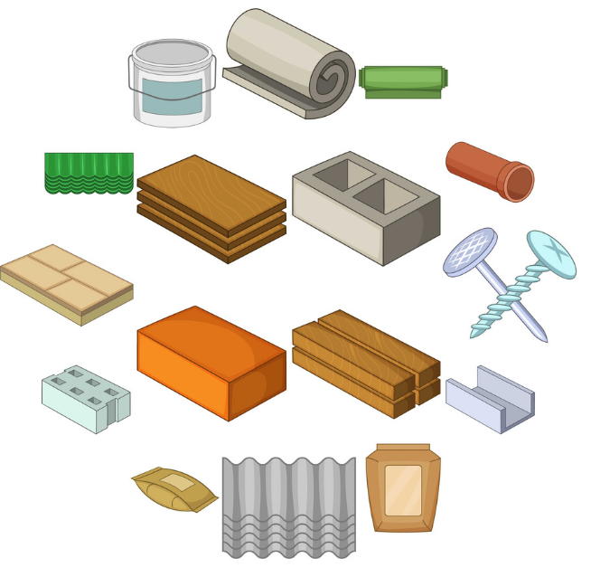  -Materials are the substances that things are made from.  -We use lots of different materials every day, e.g. metal, plastic, wood, and glass.  -Composites are made from two or more materials together.  -Different materials have different physical properties, which make them useful for different things.  - Some materials are used to make many things. |  |  | 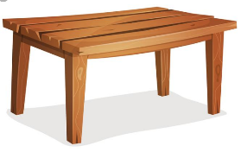  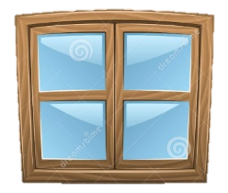  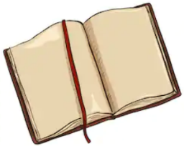 |  | Have a look around your house/ classroom and investigate what objects are made from. Often (but not always) objects are made from the materials shown below:  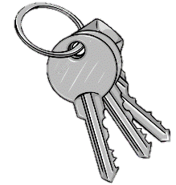  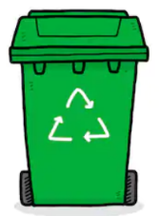  -Tables, chairs, desks, benches and book cases are often made from wood.  -Keys, taps, screws, nails, saucepans and radiators are often made from metal.  -Windows, mirrors and drinking glasses are often made from glass.  -Bins, toys, food packaging and shopping bags are often made from plastic.  -Diaries, planners, exercise books and posters are often made from paper.
Types of Materials
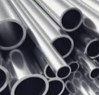  Metal  -Metals are made from rocks.  -Metal is strong and shiny.  -Metals include aluminum, iron and steel. | 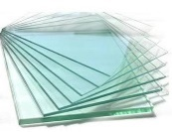  Glass  -Glass is made from fine sand.  -Glass is very strong and clear (transparent).  -Glass is used for windows and glasses.
 |  |  | Composites
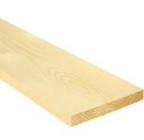  Wood  -Wood is made from trees.  -Wood is a hard and strong material.  - Woods include oak, pine and ash. | 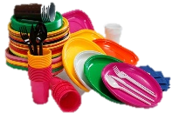  Plastic  -Plastics can be made from lots of different materials.  -Plastic can be tough or bendy, and so it is used for many different purposes.
 |  |  |  | 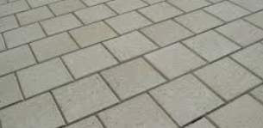
  Water  -Water is a natural material, found all over the world.  -Water is clear and can take many shapes. It can be frozen into ice or heated into gas. | 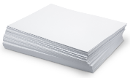  Paper  -Paper is made from trees.  -Paper is normally thin and can be made into different shapes. Lots of different things are made from paper. |  |  |  | 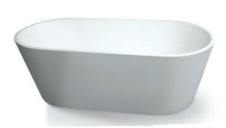

Hard Materials
Soft Materials
Glass
Plastic
Diamond
Metal
Polystyrene
Paper
Concrete
Wood
Rubber
Cotton
Fabric
Wool

