

\
ANIMALS including Humans
KNOWLEDGE ORGANISER
-Sight - Eyes help humans and most animals to see
-Hearing - Ears help humans and most animals to hear
-Smell - Noses help humans and most animals to smell
-Taste - Tongues help humans and most animals to taste
-Touch – Skin helps humans and most animals to feel
Brains helps humans and animals to think.

Overview |  |  | Animal Structures
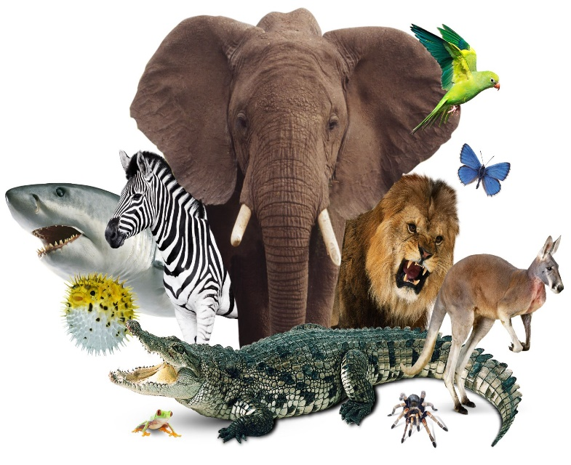  -Animals are living things.  -Like plants, animals need food and water to live.  -Unlike plants (which make their own food) animals feed themselves by eating plants or other animals.  -Animals are also able to sense (including see, hear, smell, taste, touch) what is going on around them.  -Millions of animals live on earth. |  |  |  | 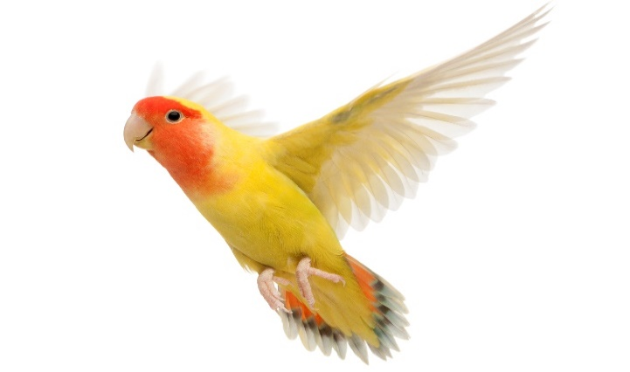  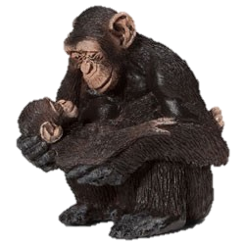 | -Birds have wings, to help them fly.  -They use beaks for eating and keeping themselves clean.  -They have light bones to make flying easier.  -Feathers are also light (helping them fly) and are important for keeping birds warm.  -Mammals have hair/ fur, to keep them warm.  -Their warm blood also keeps them and their young warm.  -Mammary glands – nipples/udders help mammals to feed their young.
Types of Animals
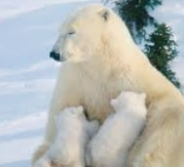
Mammals

-Mammals are warm-blooded creatures. Most have hair.

-They give birth to live young. They produce milk to feed them.

-Humans are mammals. Other examples are monkeys, lions, bears, dogs, cats and cows
 |  |  | Senses
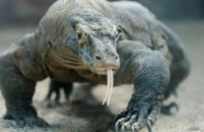  Reptiles  -Reptiles are cold-blooded. They lay eggs/ have scales. They breathe through lungs.  -Examples include lizards, crocodiles & snakes. | 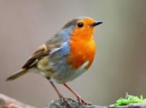  Birds  -Birds are warm-blooded. They lay eggs/ often have feathers and wings. Most have hollow bones & can fly.  -Examples include robins, penguins & ducks.
 |  |  | 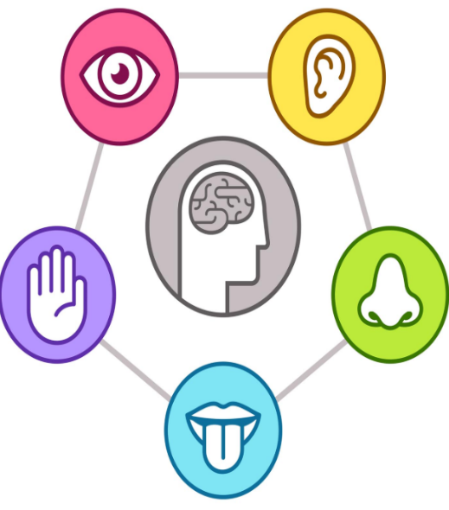
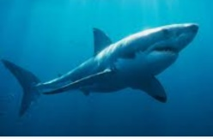  Fish  -Fish are cold-blooded and live in water. They breathe through gills. Have fins/scales.  -Examples include sharks, salmon, & rays. | 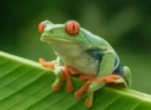  Amphibians  -Amphibians are cold-blooded. They live in water and land. They have 3 life stages: eggs, larvae, & adult.  Examples are frogs, toads & salamanders. cfrd

Carnivores (eat animals)
Omnivores (eat plants and animals)
Herbivores (eat plants)
Hyenas
Crocodiles
Lions
Lizards
Raccoons
Badgers
Brown Bears
Rabbits
Cows
Deers
Elephants
Sharks

