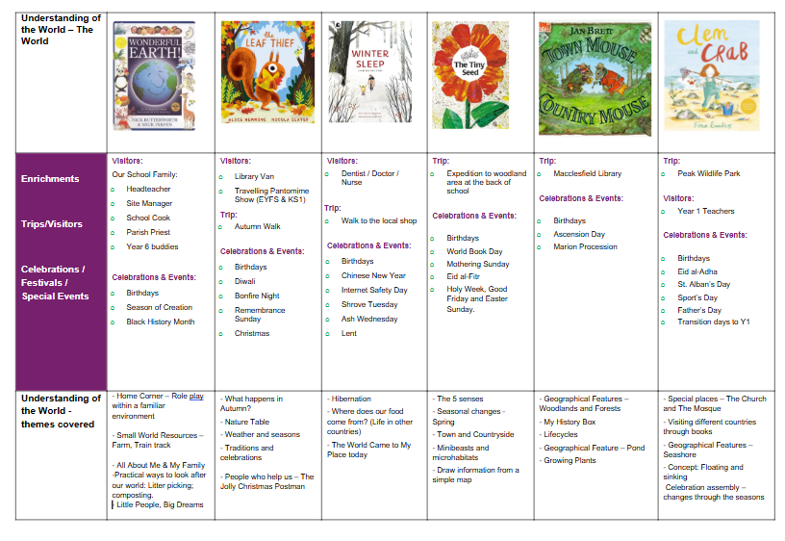

UNDERSTANDING THE WORLD □ Past and Present (KS1: History) □ People, Culture & Communities (KS1: R.E / Geography) □ Natural World (KS1: Geography / Science)

EYFS Educational Programme: Understanding the world involves guiding children to make sense of their physical world and their community. The frequency and range of children’s personal experiences increases their knowledge and sense of the world around them – from visiting parks, libraries and museums to meeting important members of society such as police officers, nurses and firefighters. In addition, listening to a broad selection of stories, non-fiction, rhymes and poems will foster their understanding of our culturally, socially, technologically and ecologically diverse world. As well as building important knowledge, this extends their familiarity with words that support understanding across domains. Enriching and widening children’s vocabulary will support later reading comprehension.
Autumn | Spring | Summer
Learning Priorities: Linked to Development Matters 2020
Past and Present  - Begin to make sense of their own life-story and family’s history  - Begin to comment on images of familiar situations in the past  - When Mum and Dad were little  People, Culture & Communities  - Talk about members of their immediate family and community  - Describe family members … grandparent, older, younger  - Understand that there are many different types of families …parent, step-sister / brother / mum / dad, similar, different  - Name and describe people who are familiar to them  - People in their local / school community… site manager, cook, shop keeper  - Begin to understand that some places are special to members of their community  - Talk about special places they go with their family  - Begin to recognise that people have different beliefs and celebrate special times in different ways  - Understand how different people celebrate birthdays  - Develop a knowledge and awareness of other festivals … Harvest, Diwali, Christmas  Natural World  - Explore the natural world around them  - Leaves □ sort by shape/size  - Describe what they see, hear and feel whilst outside  - Leaf shape, size & colour… shape and colours words e.g. long, spiky, gold, rust, orange  - Understand the effect of changing seasons on the natural world around them – Autumn into Winter  - Observe / talk about changing □ seasons … season, summer, autumn, winter □ changes in autumn … temperature, change, hibernation, darker, weather, wind  * Develop interest in linked: □ texts across themes, fiction and non-fiction □ sources of technological information | Past and Present  - Comment on images of familiar situations in the past  - Compare and contrast characters from stories, including figures from the past.  People, Culture & Communities  - Talk about members of their immediate family and community  - Name and describe people who are familiar to them  - Understand that some places are special to members of their community  - Recognise that people have different beliefs and celebrate special times in different ways  - Recognise some similarities and differences between life in this country and other countries  Natural World  - Explore the natural world around them  - Describe what they see, hear and feel whilst outside  - Understand the effect of changing seasons on the natural world around them  * Continue to develop interest in linked: □ texts across themes, fiction and non-fiction □ sources of technological information | Past and Present  - Talk about the lives of the people around them and their roles in society  - Know some similarities and differences between things in the past and now, drawing on their experiences and what has been read in class  - Understand the past through settings, characters and events encountered in books read in class and storytelling.  People, Culture & Communities  - Describe their immediate environment using knowledge from observation, discussion, stories, non-fiction texts and maps  - Know some similarities and differences between different religious and cultural communities in this country, drawing on their experiences and what has been read in class  - Explain some similarities and differences between life in this country and life in other countries, drawing on knowledge from stories, non-fiction texts and – when appropriate – maps.  Natural World  - Explore the natural world around them, making observations and drawing pictures of animals and plants  - Know some similarities and differences between the natural world around them and contrasting environments, drawing on their experiences and what has been read in class  - Understand some important processes and changes in the natural world around them, including the seasons and changing states of matter.  * Continue to develop interest in linked: □ texts across themes, fiction and non-fiction □ sources of technological information
EXPRESSIVE ARTS & DESIGN: □ Creating with Materials □ Being Imaginative & Expressive

EYFS Educational Programme: The development of children’s artistic and cultural awareness supports their imagination and creativity. It is important that children have regular opportunities to engage with the arts, enabling them to explore and play with a wide range of media and materials. The quality and variety of what children see, hear and participate in is crucial for developing their understanding, self-expression, vocabulary and ability to communicate through the arts. The frequency, repetition and depth of their experiences are fundamental to their progress in interpreting and appreciating what they hear, respond to and observe.
Autumn | Spring | Summer
Learning Priorities: Linked to Development Matters 2020
Creating with MaterialsDraw with increasing complexity and detail, such as representing a face with a circle and including details  - Continue to explore colour and colour mixing.  - Create closed shapes with continuous lines and begin to use these shapes to represent objects.  - Safely use and explore a variety of materials and tools  - Explore new techniques  - Talk about new creations  - Begin to return to and build upon previous learning  Being Imaginative & Expressive  - Take part in simple pretend play, using an object to represent something else even though they are not similar.  - Begin to develop complex stories using small world equipment like animal sets, dolls and dolls houses, etc.  - Make imaginative and complex ‘small worlds’ with blocks and construction kits, such as a city with different buildings and a park.  - Begin to develop storylines in their pretend play – including those linked to focus text … story language, character, beginning, middle, end  - Begin to listen attentively, move to and talk about music, expressing their feelings and responses  - Begin to watch and talk about dance and performance art  - What type of dance/music is it? … adjectives to describe music; e.g. happy, sad, slow, fast, bouncy  - Watch live music / dance performances linked to festivals … perform, celebrate, audience, musician , dancer  - Sing in a group or on their own  - Engage in circle and partner songs  - Begin to make own verse for familiar song  - Begin to explore and engage in music making and dance  - Invent and dance / play music to show different emotions … emotions vocabulary (see PSE) | Creating with Materials  - Explore and use a variety of artistic effects to express their ideas and feelings.  - Return to and build on their previous learning, refining ideas and developing their ability to represent them.  - Create collaboratively sharing ideas, resources and skills.  Being Imaginative & Expressive  - Listen attentively, move to and talk about music, expressing their feelings and responses.  - Watch and talk about dance and performance art, expressing their feelings and responses.  - Sing in a group or on their own, increasingly matching the pitch and following the melody.  - Explore and engage in music making and dance, performing solo or in groups.  - Develop storylines in their pretend play. | Creating with Materials  - Safely use and explore a variety of materials, tools and techniques, experimenting with colour, design, texture, form and function  - Share their creations, explaining the process they have used  - Make use of props and materials when role playing characters in narratives and stories.  Being Imaginative & Expressive  - Invent, adapt and recount narratives and stories with peers and their teacher;  - Sing a range of well-known nursery rhymes and songs;  - Perform songs, rhymes, poems and stories with others, and – when appropriate – try to move in time with music.

