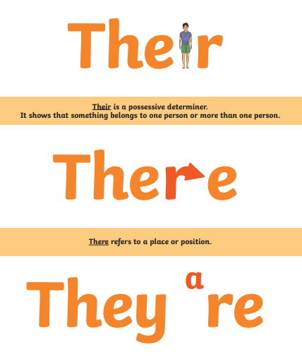

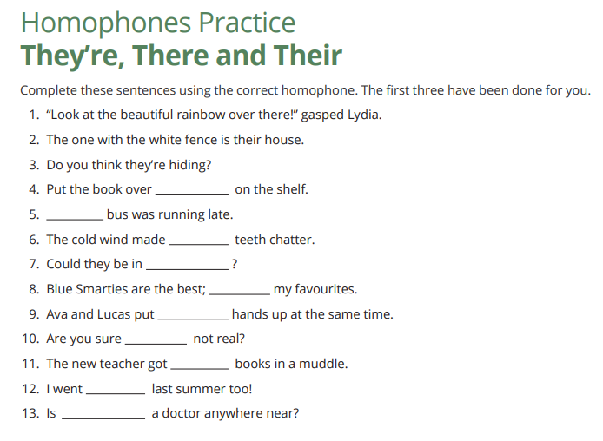

Now write 2 sentences of your own for each homophone (there, their and they’re). Your sentences should also include a fronted adverbial (punctuated with a comma).
e.g. Without hesitation, the children put on their shoes and raced out of the door.
__________________________________________________________________________________________________________________________________________________________________________________________________________________________________________________________________________________________________________________________________________________________________________________________________________________________________________________________________________________________________________________________________________________________________________________________________________________________________________________________________________________________________________________________________________________________________________________________________________________________________________________________________________________________________________________________________________________________________________________________________________________________

