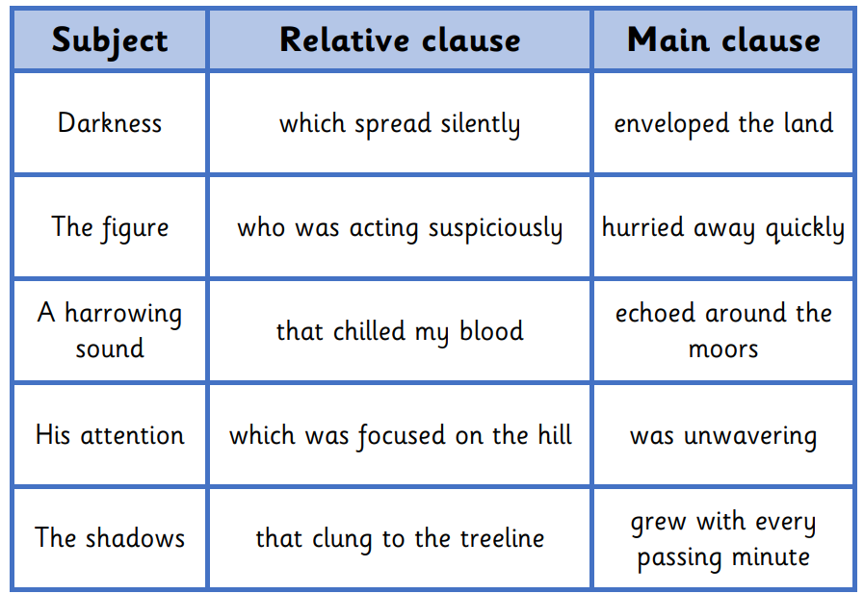
Using a subject, relative clause and main clause from the table create 5 sentences. Make sure you add in commas if needed and don’t forget your capital letters and full stops!
Challenge
Write two of your own sentences using a relative clause.

