We have been learning about expanded noun phrases. The first expanded noun phrase is made up of adjectives, a noun and a prepositional phrase. Use each given noun to generate examples for 2, 3 and 4.
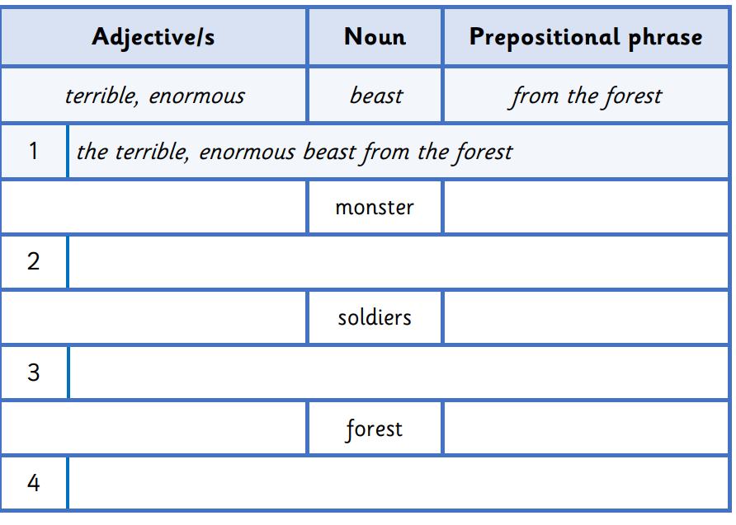

Now write three of your own complete sentences using King Kong as your inspiration, it can be about the character or setting. You must use an expanded noun phrase and make sure you are writing a complex sentence! Underline the noun phrase within your sentence.

