Activity 1
Cohesive devices, such as adverbials, are words or phrases which are useful to keep the text flowing, creating cohesion in and across paragraphs. The following table contains adverbials for time, place, frequency, manner and degree. Use the table to write five sentences about surviving in the wilderness.
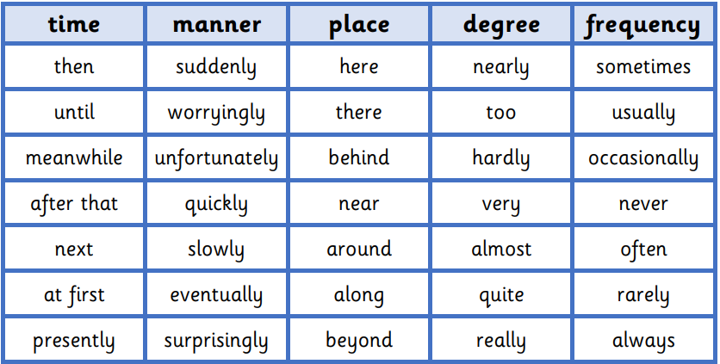
Activity 2
Read this extract from the Example Text. Highlight or underline the cohesive devices used and discuss how they help the paragraph to flow.


