Area and Perimeter of Compound Shapes Codebreaker
A | B | C | D | E | F | G | H | I | J | K | L | M
$$20$$ | $$26$$ | $$37$$ | $$35$$ | $$39$$ | $$27$$ | $$44$$ | $$40$$ | $$38$$ | $$21$$ | $$41$$ | $$24$$ | $$34$$
N | O | P | Q | R | S | T | U | V | W | X | Y | Z
$$23$$ | $$28$$ | $$43$$ | $$31$$ | $$22$$ | $$32$$ | $$30$$ | $$42$$ | $$45$$ | $$33$$ | $$29$$ | $$25$$ | $$36$$

Answer the area and perimeter questions below, link your answers to the table above to reveal what the invoice for my new chimney stated:
Find the perimeter:  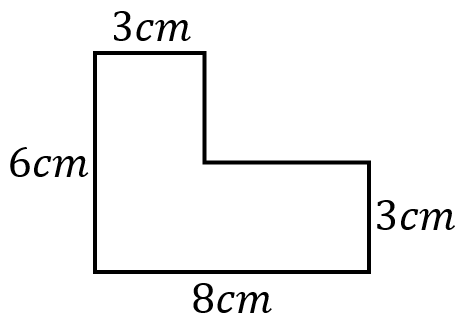 | Find the area:  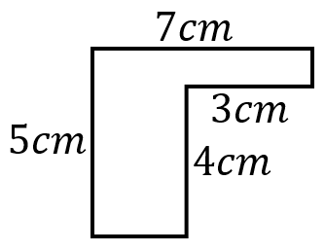 | Find the area:  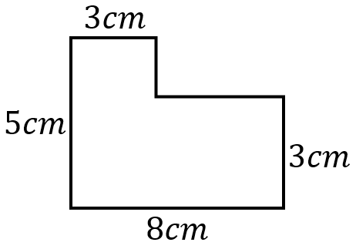 | Find the perimeter:  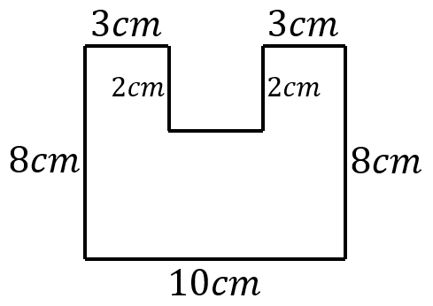 | Find the shaded area:  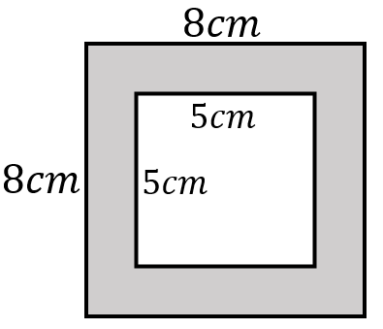
Find the perimeter:  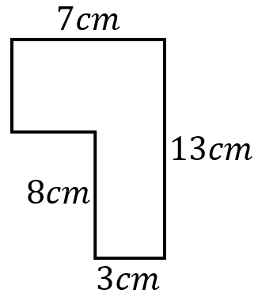 | Find the area:  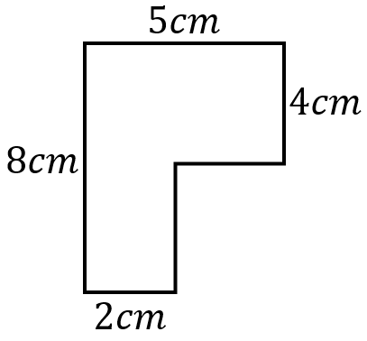 | Find the area:  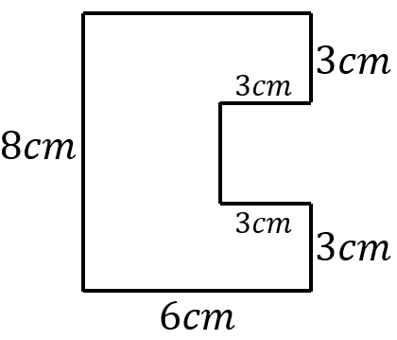 | Find the shaded area:  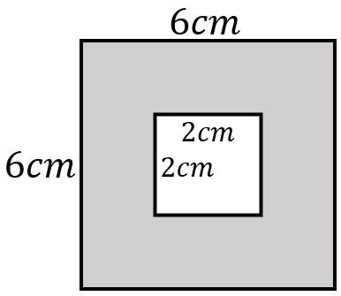 | Find the perimeter:  

