Y3 HOMEWORK 19/9/25  Dates for Diary  There will be a Parents Evening on Wednesday, 22nd October and Thursday 23rd October from 3.30 to 6.00 pm. Further details to book an appointment on line will follow.  Please do try and attend as it is an excellent opportunity to discuss your child’s progress  Thursday, 6th November: First Holy Communion Parents’ Information evening at St Alban’s Church Hall, Chester Road. 6.00 to 7.00 pm  READING LOG: Please ensure your child reads on a daily basis. Please record their reading pages e.g. from page 45 to page 65. Please date and sign. You don’t have to comment on their reading but an adult should sign the log.  Your child needs to bring their log in on the day recorded at the front of their log.  Spellings:  Group 1: Common Exception Words  Group 2: Words with the long vowel sound /a/ spelt with /ey/  If your child is in group 2, please ensure they are also able to spell the words from Group 1. In addition, please ensure your child can apply these spellings to sentences too.  English: We have now revealed our mystery book: The Iron Man by Ted Hughes illustrated by Chris Mould. Please don’t read the book with your child if you have it at home. We like to do prediction and inference with them. Next week they will write a short introduction to a story describing the Iron Man. We first look at the vocabulary to describe him and also how Hogarth and the farmers feel about encountering him. Please discuss the vocabulary your child could use. The picture of the Iron Man is below:    MATHS: Up until half term we will be investigating addition and subtraction using the column method. To start we do simple addition and subtraction where the children do not have to ‘rename’ (we used to call this carrying the ones over to the tens and the tens over to the hundreds!). We then move onto renaming. Please see an example below. The children can either mark the number they are carrying over to the next column at the bottom of the sum or at the top. Whatever they prefer. We like to model the correct language so for the following sum we would say 3 tens plus 9 tens are 13 tens = 130. We put the three tens in the tens column and carry the hundred over to the hundreds column. It is important your child understands the actual place value of the numbers they are adding.  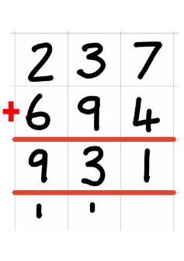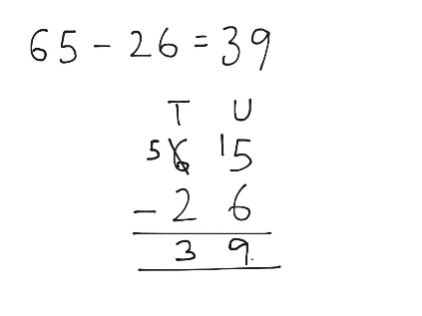  Times tables: Test every Wednesday  It is imperative your child learns them as it will be of huge benefit to them when they come to tackle short and long multiplication/division calculations later this term. There is also a formal, National Curriculum timed, times table test at the end of year 4.  Your child needs to be able to answer them in random order and understand multiplication is computation e.g. 3x2 = 6, 2 x 3 = 6. They have 40 questions to answer in 3 minutes approximately 4 seconds per question to recall them). In other words, they need to learn them! If your child gets 35 or more out of 40, they automatically move on to the next times table. Learn a few a day (e.g. 1x2 = 2, 2 x 1 = 2, 2x2 = 4, 3x2 = 6, 2x3 = 6. The next day add one more and revise them. There is also Times table Rockstars (free to use – please ask the office if you don’t have log-in and password details).  Also the BBC website has useful games and songs: https://www.bbc.co.uk/bitesize/articles/z97rdnb and  Topmarks https://www.topmarks.co.uk/maths-games/7-11-years/times-tables  PE: Outdoor PE will be on a Thursday morning and indoor PE will be on a Monday afternoon. Please ensure your child has the correct kit in school. We would politely request your child does not wear laced trainers or school shoes unless they are able to independently tie their laces. Many thanks.  If you should have any questions or concerns, please do come and find us, either at the start or end of the school day. If you should wish to have a lengthier discussion about your child, please make an appointment directly with ourselves or phone the office and we will be very happy to meet with you.  Many thanks, Year 3 Class Teachers | Y3 Group 1  you  your  where  love  come  some  one  once  ask  friend | Y3 Group 2  hey  they  obey  grey  prey  whey  survey  convey  disobey  purvey

