Y3 HOMEWORK 17.10.25  Dates for the Diary  There will be a Parents Evening on Wednesday, 22nd October and Thursday 23rd October from 3.30 to 6.00 pm. Further details to book an appointment on line will follow.  Please do try and attend as it is an excellent opportunity to discuss your child’s progress.  Half term: Last day of school Friday, 24th October  Return to school Tuesday 4th November  Please note the inset day on Monday 3rd November.  Thursday, 6th November: First Holy Communion Parents’ Information evening at St Alban’s Church Hall, Chester Road. 5.45 to 6.45 pm. Please note the change of time.  If you would like your child to receive the Sacrament of Holy Communion next June 2026, please come along to the meeting to find out about the programme and calendar of events for 2026.  READING LOG: Please ensure your child returns their reading log every week, signed. (Your child’s day is recorded at the front of their reading log).  Spellings:  Group 1: Common Exception Words  Group 2: Homophones (words that sound the same but are spelt differently and have a different meaning). Please make sure your child can apply these words to sentences  If your child is in group 2, please ensure they are also able to spell the words from Group 1.  English: Homophones worksheet attached  MATHS:  We have now started subtraction. The children need to be able to mentally calculate subtracting 1,10 and 100 from a given 3-digit number. We will also be investigating the written method of subtraction. Please see the examples below:  Mental arithmetic:  246-100= 146, 128-10 = 118 465-1 = 464  Written calculations:  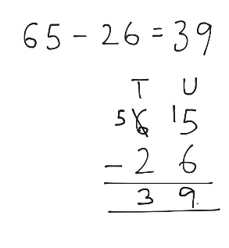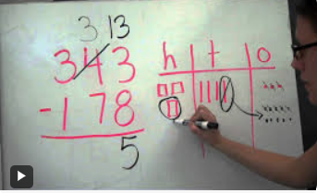  Practise sheets are attached for 2-digit and 3-digit subtraction. Your child does not have to complete both sheets. Choose the sheet most appropriate for your child.  Times tables: Test every Wednesday  It is imperative your child learns them as it will be of huge benefit to them when they come to tackle short and long multiplication/division calculations later this term. There is also a formal, National Curriculum timed, times table test at the end of year 4.  Your child needs to be able to answer them in random order and understand multiplication is computation e.g. 3x2 = 6, 2 x 3 = 6. They have 40 questions to answer in 3 minutes approximately 4 seconds per question to recall them). In other words, they need to learn themAlso the BBC website has useful games and songs: https://www.bbc.co.uk/bitesize/articles/z97rdnb and  Topmarks https://www.topmarks.co.uk/maths-games/7-11-years/times-tables  As part of Black History Month, we have been investigating the artwork of Alma Woodsey Thomas, an African American artist. Please see the Newsletter for further details. At our next Thumbs Up we hope you will come and see your child’s artwork.  PE: Outdoor PE will be on a Thursday morning and indoor PE will be on a Monday afternoon. Please ensure your child has the correct kit in school. We would politely request your child does not wear laced trainers or laced school shoes unless they are able to independently tie their laces. Many thanks.  If you should have any questions or concerns, please do come and find us, either at the start or end of the school day. If you should wish to have a lengthier discussion about your child, please make an appointment directly with ourselves or phone the office and we will be very happy to meet with you.  Many thanks, Year 3 Class Teachers | Y3 Group 1  busy  money  everybody  parents  who  beautiful  whole  plant  path  improve | Y3 Group 2  berry  bury  brake  break  meet  meat  ball  bawl  fair  fare

