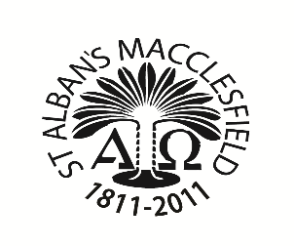
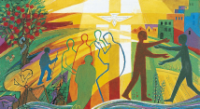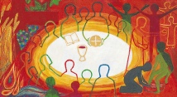
Reconciliation Eucharist

St. Alban’s RC Parish

2026 Enrolment Form
Preparing To Celebrate the Sacraments of
First Forgiveness and First Holy Communion

I/We wish our child to be enrolled for First Sacraments parish programme of preparation for the Sacraments of First Forgiveness (Reconciliation) and First Holy Communion (Eucharist).

I/We will do our best to teach and support my/our child …………………………. with their Catholic faith and sacramental preparation, by attendance at weekly Sunday Holy Mass and attending the parent’s meetings for these Sacraments. We ask the Holy Family and St. Alban to help us in the year ahead with our child’s Sacramental programme.

Child’s Name __________________________________________________________

Date of Birth ___________________________________________________________

Address ______________________________________________________________

______________________________________________________________________

Telephone No.____________________ Mobile: __________________________

Parent Email:___________________________________________________________

Current School:______________________________________________________

Parent name and signature: Date:
______________________________________________________________________

1. Parent name ________________________________________________________

RELIGION______________________________________________________________
2. Parent name_______________________________________________________

RELIGION______________________________________________________________

Enrolment Mass 2025 (circle one Mass date and time attending)
Sunday13th December 6.30 pm
Sunday14th December 9.15 am / 11.15 am / 6.30 pm

Date of Childs - Sacrament of Baptism/ name of Catholic Church, town, and country

(Please provide original child’s Baptism Certificate with this enrolment form)

For office use only confirmation of sight of original baptism cert.

Date and signature of catechist or named teacher in box.

