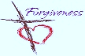
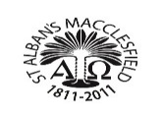
First Sacraments Programme 2026 – St. Alban’s Parish, Macclesfield
Dates 2026 | TIME | MEETING/MASSES | VENUE | NOTES
November 2025  Thurs 6th | 5.45 pm-6.45 pm | Parents Meeting  Come and See | Parish Hall | First Sacraments  Programme 2026
By 7th December |  | Enrolment Forms and Baptismal Certificates to be submitted to St Alban’s School or, if attending the Saturday group, to the Parish Office.
December  Sunday 14th | 9.15 am | Enrolment  Invitation and Medal Mass | St. Alban’s Church. | Enrolment invitation and medal
JANUARY 2026  Thursday 15th | 5.45 pm -6.45 pm | Parents Meeting – 1. Reconciliation | Parish Hall | Understanding the  Sacrament of Reconciliation
FEBRUARY  Thursday12th | 5.45 pm -6.45 pm | Parents Meeting – 2  Reconciliation | Parish Hall | God’s Love and mercy  Practice with parents
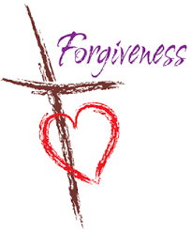  March  Saturday  7th | 9.45 am | Celebration of the Sacrament of Reconciliation – First  Forgiveness | St. Alban’s  Church | Drawing for “Zacchaeus” tree  First Forgiveness Preparation Sheets.  Celebration booklet  Sorry Prayers
Saturday 7th March  Childrens Celebration | 11.30 am – 1.00 pm | Family Celebration Party for First Forgiveness | Parish Hall | Bring and share food  Parish Hall will be open from 8.30 am
APRIL  Thursday 16th | 5.45 pm -6.45 pm | First Communion - 1 | Parish Hall | Preparing for First Communion
April  Sunday 19th | 11.15 am | Children’s Invitation Mass- First Communion | St. Alban’s Church | First Communion Medals  And Invitation Card
MAY  Thursday 21st | 5.45 pm -6.45 pm | Parents Meeting 2 Eucharist/ First Communion | Parish Hall | Reflection and Prayer. God’s love and family  Final Preparation
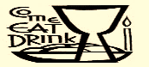  June  Saturday  13th | 10.30 am | Celebration of Sacrament of Holy Communion  Mass | St. Alban’s Church | Celebration booklet  Prayers of Intercession  By children
June  Saturday 13th | 11.30 am | Family Celebration  First Communion | Parish Hall | Celebration cake and refreshments
June  Sunday 14th | 11.15 am | Thanksgiving Mass  For First Communion | St. Alban’s  Church | First Communion clothes  optional for all children.
October  Date to be confirmed | 11.15 | Certificate Mass | St. Alban’s  Church | Sacrament of Eucharist  First Communion icon presentation

