Y3 HOMEWORK 7.11.25  Dates for the Diary  If you were unable to attend the FHC Meeting on Thursday, 6th November, please let us know you would like your child to enrol on the programme. The School Office have copies of the Enrolment Form. Please return with your child’s original Baptismal Certificate no later than 7th December to the school office. (The office will take a photocopy of your original baptismal certificate).  Sunday, 14th November: Invitation and Medal Mass, 9.15 am at St Alban’s Church.  12th November: Thumbs Up Wednesday  21st November: Non-uniform day: Bring a bottle  4th December: Thumbs Up Thursday  5th December: Christmas Fair 5-7.00 pm  Spellings:  Group 1: Common Exception Words  Group 2: Creating adverbs ending in the suffix -ly  Please ensure, if your child is in group 2 spellings they can spell the spellings in group 2.  English: Applying the homophones are and our, there, their and they’re.  MATHS: Homework: Subtraction word problems (attached). These are differentiated work sheets, please chose the most appropriate for your child. One star is the easiest, leading up to 3 stars.  We will continue to investigate the written method of subtraction, moving on to word problems. For example, 500 people are on a train, 360 of them are children. How many adults are there?  The children would still use the written methods taught to work out this type of word problem.  Written calculations:  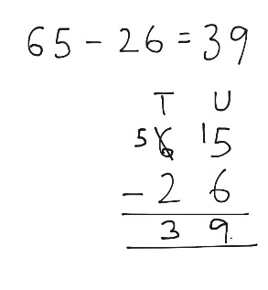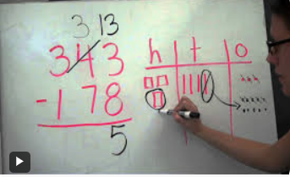  Practise sheets are attached 3-digit subtraction. Your child does not have to complete all the sheets. Choose the sheet most appropriate for your child.  Science: We will be investigating the three types of rocks sedimentary, igneous and metamorphic. Over the next half term, your child might want to start collecting pebbles/small rocks and see if they can identify them.  History: This term we will be starting our topic on the Stone Age: investigating how ‘Stone Age’ people lived and survived.  Times tables: Test every Wednesday  It is imperative your child learns them as it will be of huge benefit to them when they come to tackle short and long multiplication/division calculations later this term. There is also a formal, National Curriculum timed, times table test at the end of year 4.  Your child needs to be able to answer them in random order and understand multiplication is computation e.g. 3x2 = 6, 2 x 3 = 6. They have 40 questions to answer in 3 minutes approximately 4 seconds per question to recall them). In other words, they need to learn themAlso the BBC website has useful games and songs: https://www.bbc.co.uk/bitesize/articles/z97rdnb and  Topmarks https://www.topmarks.co.uk/maths-games/7-11-years/times-tables  As part of Black History Month, we have been investigating the artwork of Alma Woodsey Thomas, an African American artist. Please see the Newsletter for further details. At our next Thumbs Up we hope you will come and see your child’s artwork.  PE: Outdoor PE will be on a Thursday morning and indoor PE will be on a Monday afternoon. Please ensure your child has the correct kit in school. We would politely request your child does not wear laced trainers or laced school shoes unless they are able to independently tie their laces. Many thanks.  If you should have any questions or concerns, please do come and find us, either at the start or end of the school day. If you should wish to have a lengthier discussion about your child, please make an appointment directly with ourselves or phone the office and we will be very happy to meet with you.  Many thanks, Year 3 Class Teachers | Y3 Group 1  prove  move  every  climb  eye  should  many  sure  sugar  break | Y3 Group 2  kindly  quickly  safely  rudely  sweetly  strongly  bravely  secretly  finally  usually

