Y3 HOMEWORK 14.11.25  Dates for the Diary  If you were unable to attend the FHC Meeting on Thursday, 6th November, please let us know if you would like your child to enrol on the programme. The School Office have copies of the Enrolment Form. Please return with your child’s original Baptismal Certificate no later than 7th December to the school office. (The office will take a photocopy of your child’s original baptismal certificate).  Sunday, 14th November: Invitation and Medal Mass, 9.15 am at St Alban’s Church.  21st November: Non-uniform day: bring a bottle  28th November Non-uniform day: bring in chocolate  4th December: Thumbs Up Thursday  5th December: Christmas Fair 5-7.00 pm  11th December: Christmas jumper day.  12th December: Santa Dash (fundraising event for East Cheshire Hospice).  17th December: Christmas Dinner Day  Spellings:  Group 1: Common Exception Words  Group 2: Creating adverbs ending in the suffix -ly  (When The toot word ends in ‘y’ and has more than one syllable)  Please ensure, if your child is in group 2 spellings they can spell the spellings in group 1.  English: Contractions and Possessive apostrophe (homework attached).  MATHS: Homework. Ensure your child has explored the x3, x4 and x8 tables. Next week we will start multiplication moving onto division. We start with exercises where the children will focus on x3, x4 and x8. We do, of course, use resources to help the children but it is much quicker if your child has learnt their tables and is confident at speedily recalling them in random order. In addition, knowing their times tables will greatly assist your child in division as it is the inverse of multiplication.  4x 8 = 32  32÷8 = 4  (if they don’t their tables, they will either draw it or use resources to work the sum out. It is much quicker if they know their tables!)  After a few weeks we will move onto further multiplication. We used the expanded method and move onto the compact method (below):  Expanded:  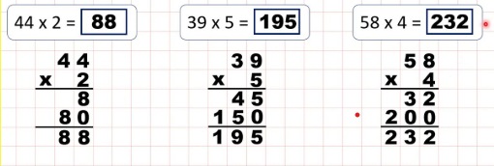  Compact method:  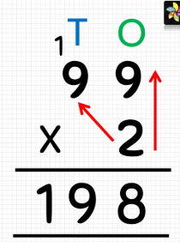  Division:  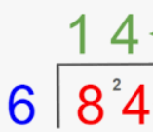  Science: We are investigating the three types of rocks sedimentary, igneous and metamorphic. Over the next half term, your child might want to start collecting pebbles/small rocks and see if they can identify them.  History: This term we will be starting our topic on the Stone Age: investigating how ‘Stone Age’ people lived and survived.  Times tables: Test every Wednesday    As well as Timestable Rockstars, the BBC website has useful games and songs: https://www.bbc.co.uk/bitesize/articles/z97rdnb  and  Topmarks https://www.topmarks.co.uk/maths-games/7-11-years/times-tables  PE: Outdoor PE will be on a Thursday morning and indoor PE will be on a Monday afternoon. Please ensure your child has the correct kit in school. We would politely request your child does not wear laced trainers or laced school shoes unless they are able to independently tie their laces. Many thanks.  If you should have any questions or concerns, please do come and find us, either at the start or end of the school day. If you should wish to have a lengthier discussion about your child, please make an appointment directly with ourselves or phone the office and we will be very happy to meet with you.  Many thanks, Year 3 Class Teachers | Y3 Group 1  break  steak  great  told  gold  hold  even  half  people  pretty | Y3 Group 2  happily  angrily  lazily  easily  busily  greedily  messily  wearily  cheekily  clumsily

