Y3 HOMEWORK 21.11.25  Please ensure your child comes to school in adequate warm and rainproof gear every day. The children go out to play regardless of the weather.  Dates for the Diary.  FHC: Enrolment Forms available in the office. Please return with your child’s original baptismal certificate by Thursday, 6th December (The office will take a photocopy of your child’s baptismal certificate).  Sunday, 14th December: Invitation and Medal Mass, 9.15 am at St Alban’s Church.  21st November: Non-uniform day: bring a bottle  28th November Non-uniform day: bring in chocolate  4th December: Thumbs Up Thursday  5th December: Christmas Fair 5-7.00 pm  11th December: Christmas jumper day.  12th December: Santa Dash (fundraising event for East Cheshire Hospice).  17th December: Christmas Dinner Day  Spellings:  Group 1: Common Exception Words: A total of 11 this week. This set of spellings now completes all the Common Exception Words for Year 2 covered since the start of the school year). Please do keep revising the ones previously taught to ensure they are firmly embedded).  Group 2: Creating adverbs ending in the suffix -ly  (When The toot word ends in ‘le’).  Please ensure if your child is in group 2 spellings they can spell the words in group 1.  English: Prepositions. As the root word suggests, prepositions tell us the position of something in relation to something else e.g. under, over, next to etc. There are prepositions of time e.g after, during, since etc.  MATHS: Homework. Word problems using the x3, x4 and x8 tables.  Ensure your child has explored the x3, x4 and x8 tables. We have started multiplication moving onto division. We start with exercises where the children will focus on x3, x4 and x8. We do, of course, use resources to help the children but it is much quicker if your child has learnt their tables and is confident at speedily recalling them in random order. In addition, knowing their times tables will greatly assist your child in division as it is the inverse of multiplication.  4 x 8 = 32  32÷8 = 4  (if they don’t know their tables, they will either draw it or use resources to work the sum out. It is much quicker if they know them).  After a few weeks we will move onto further multiplication. We used the expanded method and move onto the compact method (below):  Expanded:  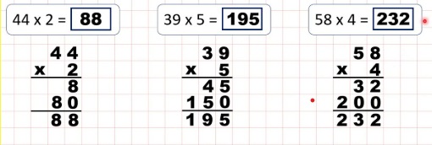  Compact method:  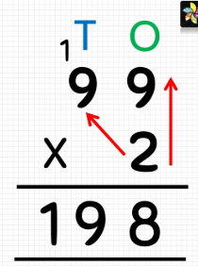  Division:  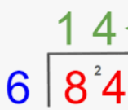  Science: We are investigating the three types of rocks sedimentary, igneous and metamorphic. Over the next half term, your child might want to start collecting pebbles/small rocks and see if they can identify them.  History: This term we will be starting our topic on the Stone Age: investigating how ‘Stone Age’ people lived and survived.  Times tables: Test every Wednesday    As well as Timestable Rockstars, the BBC website has useful games and songs: https://www.bbc.co.uk/bitesize/articles/z97rdnb  and  Topmarks https://www.topmarks.co.uk/maths-games/7-11-years/times-tables  If you should have any questions or concerns, please do come and find us, either at the start or end of the school day. If you should wish to have a lengthier discussion about your child, please make an appointment directly with ourselves or phone the office and we will be very happy to meet with you.  Many thanks, Year 3 Class Teachers | Y3 Group 1  grass  pass  class  fast  last  past  father  could  would  any  bath | Y3 Group 2  gently  simply  humbly  nobly  horribly  terribly  possibly  incredibly comfortably probably

