Y3 HOMEWORK 28.11.25  Please ensure your child comes to school in adequate warm and rainproof gear every day. The children go out to play regardless of the weather.  Dates for the Diary.  FHC: Enrolment Forms available in the office. Please return with your child’s original baptismal certificate no later than Friday, 5th December (The office will take a photocopy of your child’s baptismal certificate).  Sunday, 14th December: Invitation and Medal Mass, 9.15 am at St Alban’s Church.  4th December: Thumbs Up Thursday  5th December: Christmas Fair 5-7.00 pm  11th December: Christmas jumper day.  12th December: Santa Dash (fundraising event for East Cheshire Hospice).  17th December: Christmas Dinner Day  Spellings:  Group 1: We are now moving onto the year 3 common exception words.  Group 2: Creating adverbs ending in the suffix -ly  (When The toot word ends in ‘le’).  Please ensure if your child is in group 2 they can spell the words in group 1. These are words that regularly appear in termly spelling tests.  English: Adverbs. An adverb is a word that describes a verb (an action word) and tells us how, when, or where the action happened. Many adverbs end in "-ly," like "quickly" and "happily," but many do not, such as "fast," "yesterday," or "here". For example, in the sentence "The dog ran quickly," the word "quickly" is an adverb because it describes how the dog ran.  MATHS:. Maths homework in St Alban’s School is now being set on line. Please see the attached sheet which explains how to log on. It also contains a unique password to your child can access the work allocated to them.  Ensure your child has explored the x3, x4 and x8 tables. We have started multiplication moving onto division. We start with exercises where the children will focus on x3, x4 and x8. We do, of course, use resources to help the children but it is much quicker if your child has learnt their tables and is confident at speedily recalling them in random order. In addition, knowing their times tables will greatly assist your child in division as it is the inverse of multiplication.  4 x 8 = 32  32÷8 = 4  (if they don’t know their tables, they will either draw it or use resources to work the sum out. It is much quicker if they know them).  After a few weeks we will move onto further multiplication. We used the expanded method and move onto the compact method (below):  Expanded:  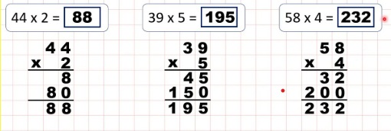  Compact method:  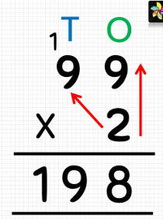  Division:  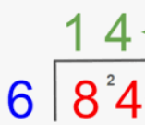  History: So far in history, we have investigated when the Stone Age was in relation to other key events in history. We have researched archaeological sources of evidence and this week we have discussed what being a hunter-gatherer meant for Stone Age people.  Times tables: Test every Wednesday    As well as Timestable Rockstars, the BBC website has useful games and songs: https://www.bbc.co.uk/bitesize/articles/z97rdnb  and  Topmarks https://www.topmarks.co.uk/maths-games/7-11-years/times-tables  If you should have any questions or concerns, please do come and find us, either at the start or end of the school day. If you should wish to have a lengthier discussion about your child, please make an appointment directly with ourselves or phone the office and we will be very happy to meet with you.  Many thanks, Year 3 Class Teachers | Y3 Group 2  address  although  answer  appear  arrive  believe  bicycle  build  busy  business | Y3 Group 2  basically  frantically dramatically magically  tragically  comically  actually accidentally occasionally eventually

