Y3 HOMEWORK 5.12.25  Dates for the Diary.  Please ensure your child’s baptismal certificate and enrolment form are submitted no later than Monday, 8th December if you wish your child to receive the Sacrament of First Holy Communion in June 2026. They will be receiving their invites the following Sunday, 14th December.  Tonight, 5.12.25, Christmas Fair. We look forward to seeing you.  11th December: Christmas jumper day.  12th December: Santa Dash (fundraising event for East Cheshire Hospice).  16th December: KS2 Carol Service at St Alban’s Church 6.00 pm.  17th December: Christmas Dinner Day  19th December: Non-uniform. Christmas movie in class and Christmas activities.  Spellings:  Group 1: We have now moved onto the year 3 common exception words (words that don’t follow a spelling pattern).  Group 2: Creating adverbs ending in the suffix -ly  (exceptions to the rule).  Please ensure if your child is in group 2 they can spell the words in group 1. These are words that also regularly appear in termly spelling tests.  English: Direct Speech. Using inverted commas (speech marks) to indicate when a person is talking.  MATHS: Maths homework in St Alban’s School is now being set on line. Last week, your child was given a log-in password for maths.co.uk. Please ensure your child completes their homework.  Ensure your child has explored the x3, x4 and x8 tables. We are exploring division and its relation to multiplication. We have investigated the word ‘inverse’ and thought about how are knowledge of times tables can help us answer division questions focusing on the x3, x4 and x8. We do, of course, use resources to help the children but it is much quicker if your child has learnt their tables and is confident at speedily recalling them in random order. In addition, knowing their times tables will greatly assist your child in division as it is the inverse of multiplication.  4 x 8 = 32  32÷8 = 4  (if they don’t know their tables, they will either draw it or use resources to work the sum out. It is much quicker if they know them).  After a few weeks we will move onto further multiplication. We used the expanded method and move onto the compact method (below):  Expanded:  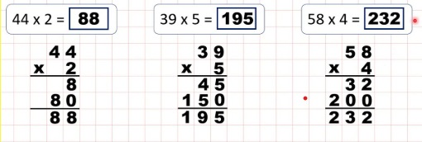  Compact method:  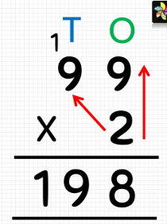  Division:  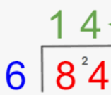  History: So far in history, we have investigated when the Stone Age was in relation to other key events in history. We have researched archaeological sources of evidence; how homes evolved for Stone Age people. This week we have investigated foods available to Stone Age people and the necessity to forage and hunt for all their food.  Times tables: Test every Wednesday    As well as Timestable Rockstars, the BBC website has useful games and songs: https://www.bbc.co.uk/bitesize/articles/z97rdnb  and  Topmarks https://www.topmarks.co.uk/maths-games/7-11-years/times-tables  If you should have any questions or concerns, please do come and find us, either at the start or end of the school day. If you should wish to have a lengthier discussion about your child, please make an appointment directly with ourselves or phone the office and we will be very happy to meet with you.  Many thanks, Year 3 Class Teachers | Y3 Group 2  calendar  caught  centre  century  certain  circle  complete  consider  continue  decide | Y3 Group 2  truly  duly  wholly  fully  daily  publicly  slyly  shyly  coyly

