Y3 HOMEWORK 9.1.26  Dates for the Diary.  FHC Meeting: Thursday 15th January from 5.45 pm to 6.45 pm. St Alban’s Parish Hall.  Monday, 19th January. Fox research (see notes under English below).  Spellings:  Group 1: We have now moved onto the year 3 common exception words (words that don’t follow a spelling pattern).  Group 2: Words with short /i/ sound spelt with ‘y’  Please ensure if your child is in group 2 they can spell the words in group 1. These are words that also regularly appear in termly spelling tests.  English: Next week the children will start their new topic on non-chronological report writing. They will be writing a report on the subject of Foxes. Your child has been asked to research their habitat: dens but also where they can be found in the world e.g. desert, arctic, forests etc; diet; young; interesting facts that do not fall under the above categories. We are very happy for your child to use the internet but it is essential they understand the wording and any technical language used. (We don’t want reams of research they haven’t read or understand).  Research to be completed by Monday, 19th January.  MATHS: Maths homework in St Alban’s School is now being set on line.  Maths Topic: multiplication and division  We use the following methods: first the expanded method and move onto the compact method (below):  Expanded:  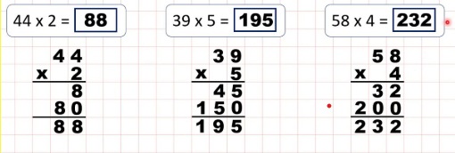  Compact method:  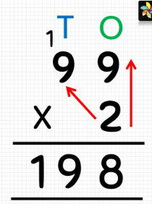  Division:  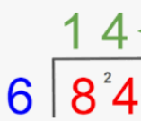  Geography: Our topic this term is ‘Where in the World?’: we will be investigating lines of latitude and longtitude to help us locate countries and continents (the imaginery lines of the Equator, Capricorn and Cancer, Arctic and Antarctic). We will also investigate why we have different time zones.  Times tables: Test every Wednesday    As well as Timestable Rockstars, the BBC website has useful games and songs: https://www.bbc.co.uk/bitesize/articles/z97rdnb  and  Topmarks https://www.topmarks.co.uk/maths-games/7-11-years/times-tables  If you should have any questions or concerns, please do come and find us, either at the start or end of the school day. If you should wish to have a lengthier discussion about your child, please make an appointment directly with ourselves or phone the office and we will be very happy to meet with you.  Many thanks, Year 3 Class Teachers | Y3 Group 1  describe  different  difficult  disappear  early  earth  eight  eighth  enough  exercise | Y3 Group 2  myth  gym  Egypt  pyramid  mystery  hymn  system  symbol  lyric  typical

