Y3 HOMEWORK 16.1.26  Dates for the Diary.  Monday, 19th January. Fox research to be completed and submitted. (see notes under English below).  MATHS: Online at maths.co.uk Maths. Homework in St Alban’s School is now being set on line. All children must complete this homework. It is not optional. Every child was given a password to log on and this was sent home with them before Christmas. However, if this has been misplaced please request another log-in.  Maths Topic: Further multiplication. Next week we will investigate division. Methods given below.  Please review the methods below with your child as they would all benefit from extra practise at home.  We have been investigating the expanded method of multiplication and have been comparing this method with the compact method. Next week we will move on to division.  Expanded:  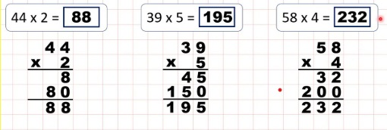  Compact method:  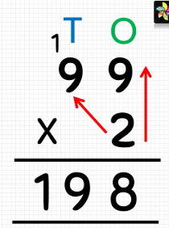  Division:  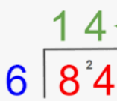  Spellings:  Group 1: We have now moved onto the year 3 common exception words (words that don’t follow a spelling pattern).  Group 2: Adding the vowel suffixes –er, -ed or -ing  Please ensure, if your child is in group 2, they can spell the words in group 1. These are words that also regularly appear in termly spelling tests.  Reminder: English: Please return their research no later than Monday 19th January. We have been investigating the features of a non-chronological report and the use of formal and technical language.  Your child will be writing their own report on Foxes. Your child has been asked to research their habitat: dens but also where they can be found in the world e.g. desert, arctic, forests etc; diet; young; interesting facts that do not fall under the above categories.  We are very happy for your child to use the internet but it is essential they understand the wording and any technical language used. (We don’t want reams of research they haven’t read or understand).  Geography: We have been investigating lines of latitude on a World Map: the Equator, the Tropic of Cancer and Capricorn and lines of longitude: the Prime Meridian. We have identified countries along these lines on a globe. If you would like to continue to explore these lines of latitude further at home on a world map that would be even better. This will allow further exploration to precisely pin point the countries these lines of latitude go through.  Times tables: Test every Wednesday    As well as Timestable Rockstars, the BBC website has useful games and songs: https://www.bbc.co.uk/bitesize/articles/z97rdnb  and  Topmarks https://www.topmarks.co.uk/maths-games/7-11-years/times-tables  If you should have any questions or concerns, please do come and find us, either at the start or end of the school day. If you should wish to have a lengthier discussion about your child, please make an appointment directly with ourselves or phone the office and we will be very happy to meet with you.  Many thanks, Year 3 Class Teachers | Y3 Group 1  experience  extreme  famous  favourite  february  forward  forwards  fruit  grammar  group | Y3 Group 2  gardener  gardening  limited  limiting  offering  offered  benefited  benefiting  focused  focusing

