Y3 HOMEWORK 23.1.26  Dates for the Diary.  Tuesday 3rd February: Thumbs up Tuesday  Friday 13th February: school closes for half term.  Saturday 7th March: Sacrament of First Forgiveness.  Please ensure your child completes their online maths homework, spellings and, when set, any additional English tasks. Homework is an expected part of learning and should be completed each week.  We do, however, appreciate that there may be occasions when homework cannot be completed due to other commitments. If this is the case, please let us know.  Science: Topic this week: Investigating Reflective Services Revision and fun quiz  https://www.bbc.co.uk/bitesize/articles/zy34r2p  English homework: Over the last few weeks we have been investigating main and subordinate clauses. Attached is a mini test for your child to complete. (A PowerPoint has also been saved on the school website in our class homework folder for revision/provide extra help on the differences between main and subordinate clauses).  Maths Topic: Homework on Maths.co.uk.  This week we have been investigating the compact method of division. Method given below.  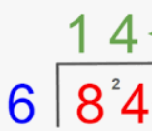  Please continue to review the methods below with your child as they will all benefit from extra practise at home.  Expanded:  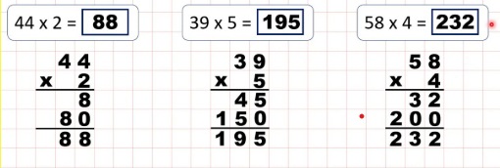  Compact method:  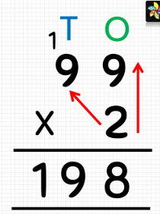  Spellings:  Group 1: Year 3 common exception words (words that don’t follow a spelling pattern).  Group 2: Adding suffixes beginning with a vowel (er/ed/ing/en) to words with more than one syllable (stressed last syllable - double the final consonant)  Please ensure, if your child is in group 2, they can spell the words in group 1. These are words that also regularly appear in termly spelling tests.  Geography: We have been investigating:  - lines of latitude and lines of longitude and how the world is divided into the Northern and Southern hemispheres. Children have drawn the Equator on their own world globes and have identified countries along this imaginary line.  - Why we have day and night.  - Greenwich Mean Time and Time Zones around the  - world.  In RE we have explored what it means to create the Kingdom of God here on Earth and how our deeds and actions can affect those around us.  Times tables: Test every Wednesday    As well as Timestable Rockstars, the BBC website has useful games and songs: https://www.bbc.co.uk/bitesize/articles/z97rdnb  and  Topmarks https://www.topmarks.co.uk/maths-games/7-11-years/times-tables  If you should have any questions or concerns, please do come and find us, either at the start or end of the school day. If you should wish to have a lengthier discussion about your child, please make an appointment directly with ourselves or phone the office and we will be very happy to meet with you.  Many thanks, Year 3 Class Teachers | Y3 Group 1  guide  heard  heart  height  history  imagine  increase  important  interest  island | Y3 Group 2  forgetting  forgotten  beginning  beginner  preferred  preferring  occurred  occurring  forbidden  committed

