Y3 HOMEWORK 24.4.26  This week: online maths homework at www.maths.co.uk  Maths Topic:  Money  Word problems: The children have started to tackle word problems. Below is an example of the type of word problem we investigate.  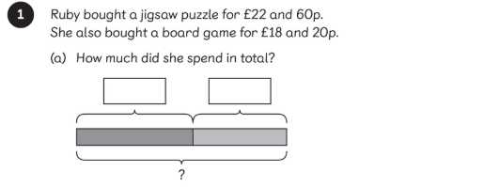  Towards the end of next week: Time. It would be useful if you would spend some time with your child investigating an analogue clock.  Overall learning objective:  To tell and write the time from an analogue clock, including using Roman numerals from I to XII, and 12-hour and 24-hour clocks.  Below are the types of questions covered in Maths No Problem.  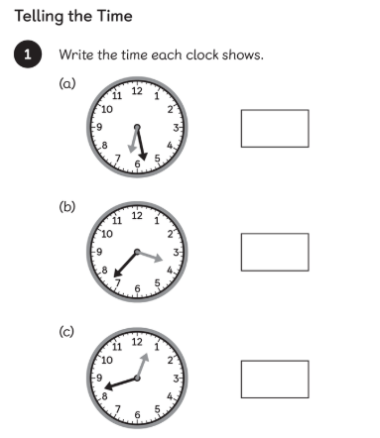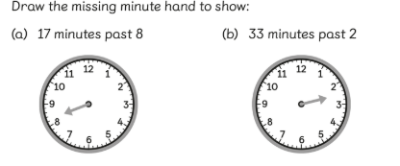  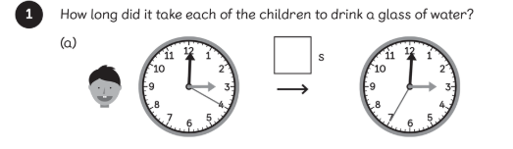  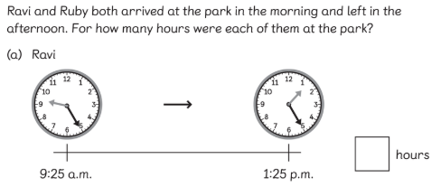  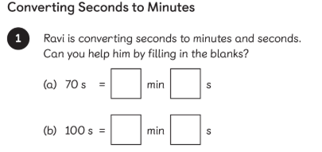  Useful websites:  Time  https://www.bbc.co.uk/bitesize/topics/zhk82hv (revision KS1)  https://www.bbc.co.uk/bitesize/topics/zkfycdm (KS2)  English:  Handwriting practice and learning spellings.  The spellings over the next few weeks are the common exception words for year 2 and the statutory spelling words for year 3.  Times tables: Test every Wednesday    As well as Timestable Rockstars, the BBC website has useful games and songs: https://www.bbc.co.uk/bitesize/articles/z97rdnb  And Topmarks https://www.topmarks.co.uk/maths-games/7-11-years/times-tables  If you should have any questions or concerns, please do come and find us, either at the start or end of the school day. If you should wish to have a lengthier discussion about your child, please make an appointment directly with ourselves or phone the office and we will be very happy to meet with you.  Many thanks, Year 3 Class Teachers. | group 1 and 2  Common Exception Words  circle  complete  consider  continue  decide  describe  different  difficult  disappear  early  (the one’s highlighted in yellow are regularly used and often misspelt in the children’s writing)

