Y3 HOMEWORK 8.5.26  Dates for the Diary  Thursday, 21st May: FHC Meeting in the Church Hall at 5.45 pm.  Last day of this half term Friday, 22.5.26  Please note the new date for our Year 3 class assembly which has been moved to Friday 5th June.  Geography: Homework: Your child has been asked to research a coastal region.  They can choose a place they may have already visited or would like to visit. Their research needs to cover:  - The major physical (natural) features of the region. For example, the limestone arch of Durdle Door, the Seven Sisters Chalk cliffs near Brighton, Lulworth Cove in Dorset.  - The human (man-made) features of their chosen region. For example, Blackpool Pleasure Beach, the lighthouse in Southwold or Brighton Palace Pier.  Please choose just one coastal area/resort to research its human and physical features.  The children’s research will form part of a poster they will produce and share with the class in school. They can draw or bring in pictures of the features of their chosen resort. Please do not bring in reams of on-line research the children have not written/typed themselves. The children need to understand the vocabulary used and be able to understand and explain their research.  Please ensure this homework is returned no later than Wednesday 20th May.  Maths  online maths homework at www.maths.co.uk  Our topic is time:  Examples of questions we will be investigating next week:  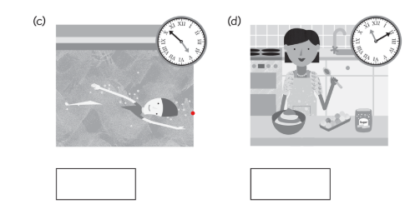  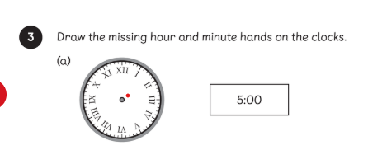  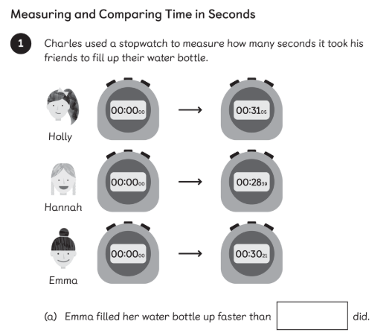  Useful websites:  Time  https://www.bbc.co.uk/bitesize/topics/zhk82hv (revision KS1)  https://www.bbc.co.uk/bitesize/topics/zkfycdm (KS2)  Handwriting practice and learning spellings.  The spellings over the next few weeks are the common exception words for year 2 and the statutory spelling words for year 3.  Times tables: Test every Wednesday    As well as Timestable Rockstars, the BBC website has useful games and songs: https://www.bbc.co.uk/bitesize/articles/z97rdnb  And Topmarks https://www.topmarks.co.uk/maths-games/7-11-years/times-tables  If you should have any questions or concerns, please do come and find us, either at the start or end of the school day. If you should wish to have a lengthier discussion about your child, please make an appointment directly with ourselves or phone the office and we will be very happy to meet with you.  Many thanks, Year 3 Class Teachers. | Common Exception Words  February  forward  forwards  fruit  grammar  group  guard  guide  heart  and  the homophones  heard  through  would  (often spelt herd, threw and wood in the wrong context– please review/revise their different meanings).

