Y3 HOMEWORK 26.6.26  Important dates for the Diary  Inset Day: tomorrow, Friday, 26th June. School closed for staff training.  Friday, 3rd July, Summer BBQ and Fair. 5.00-7.30 pm  KS2 Sports day 10th July 9.15 am (please ensure your child has their outdoor PE Kit and a drink bottle of water).  Parents’ ‘Drop In’ 14th July 3.45 to 5.00 pm  Friday, 17th July. Last day of term.  Art and D&T  Next week, in Design and Technology, the children will be designing and making a castle using nets, 3D shapes and junk-modelling materials.  To help with this project, we would be very grateful if children would bring in any suitable cardboard materials they may wish to use for their model. Useful items might include small cardboard boxes, cereal boxes, empty kitchen roll tubes and other clean recycling materials.  Please send any materials into school by Tuesday 7th July.  Thank you for your continued support.  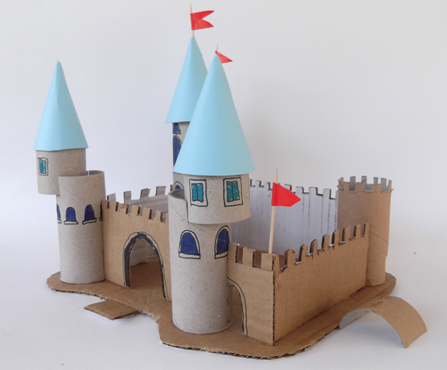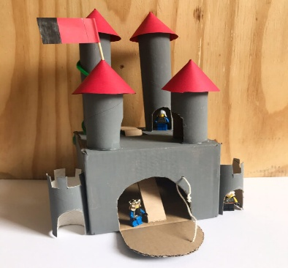  Space Rockets (optional homework).  In addition, we are inviting the children to construct a space rocket at home. Rockets should be brought into school on Tuesday 14th July. (Please do not bring the rockets in before this date as we don’t have room to store them). There will be a prize for the two best rockets.  Two Prize Categories:  🏆 Most Creative Rocket: For the rocket that shows the most imagination, originality or artistic flair.  🏆 Best Engineered Rocket: For the rocket that demonstrates excellent construction, attention to detail and thoughtful design.  Some ideas:  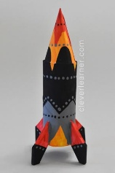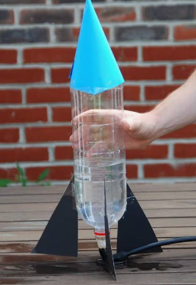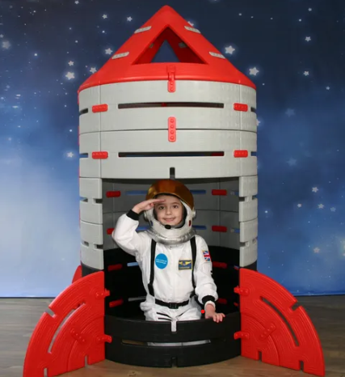  Reminder: Science homework (to be returned by Monday, 29th June).  For out topic on ‘Space’, please would the children complete some research on the life of an astronaut: training; space/flight suits, diet and day to day living on a space rocket. If your child has any books they would like to share on this topic, please feel free to bring them into school.  Curriculum  - recognise angles as a property of shape or a description of a turn  - identify right angles, recognise that 2 right angles make a half-turn, 3 make three-quarters of a turn and 4 a complete turn; identify whether angles are greater than or less than a right angle  - identify horizontal and vertical lines and pairs of perpendicular and parallel lines  Useful websites: Lines and angles - Year 3 Maths - BBC Bitesize  Right angles KS2 | Y3 Maths | Lesson Resources | Oak National Academy  Maths  online maths homework at www.maths.co.uk  Spellings: Please learn these at home with your child. These are important common exception words (they don’t follow a specific spelling pattern).  Times tables: Test every Wednesday    As well as Timestable Rockstars, the BBC website has useful games and songs: https://www.bbc.co.uk/bitesize/articles/z97rdnb  And Topmarks https://www.topmarks.co.uk/maths-games/7-11-years/times-tables  With thanks, Year 3 Teachers. | Common Exception Words  reign  remember  sentence  separate  special  straight  strange  strength  suppose  surprise  and  reappear  something (often spelt somefing!)

