Holiday Homework: Friday 14th February
Advance Notice: Thursday 20th March
Stockport Air Raid Shelters
You might want to use the half term break to prepare your Evacuee costume. 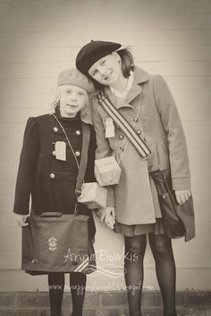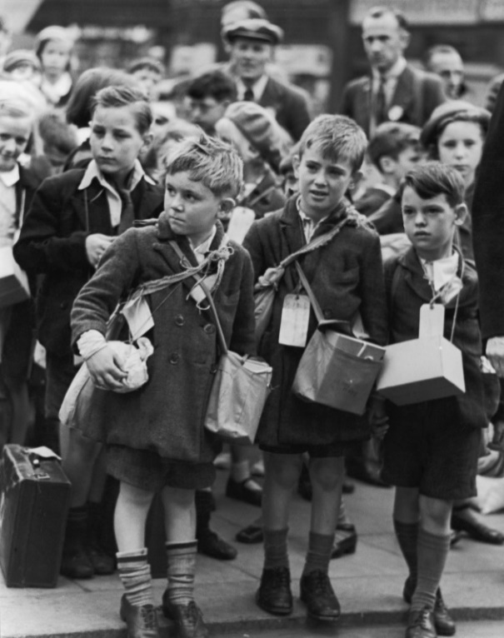
You could use these pictures as a guide.
Clothing suggestions:
Boys should preferably wear short trousers, shirt, jumpers, tank top, jacket, cap, shoes.
Girls should preferably wear a dress/ skirt and jumper, coat, beret, hair in bunches/ribbons, tights or socks with shoes.
Gask Mask Box
You will need to make a gas mask box to hold your packed lunch so you need to make sure the box has a lid. You could decorate the box with suitable gas mask labels. (A cereal box/ small washing powder box covered in brown paper with a string handle is ideal.) See picture for ideas.

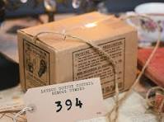
ARTIST STUDY HOMEWORK
As part of our Art work this term, you need to study one artist in depth.

Your Task: Research one artist of your choice.
Size: up to A3.
Produce a fact file about him or her. Include facts about his/her life/background in Art/what inspired them/ at least 3 examples of Art work/ pictures of this art work and of the artist.

Include your thoughts about the artist’s style.

GUIDED READING
Make sure that you finish your book if it has been set.

World Book Day: Thursday 6th March
Please note that you will all be dressing up in a World Book Day Costume. This is to give you time to organise your costume over the half term break.

Enjoy your break!

