Please practise reading these words with your child. Encourage your child to sound out each word and then blend. Page 1 are real words and page 2 are alien. Please practise all of the words ahead of the Phonics Screening Check after half term.
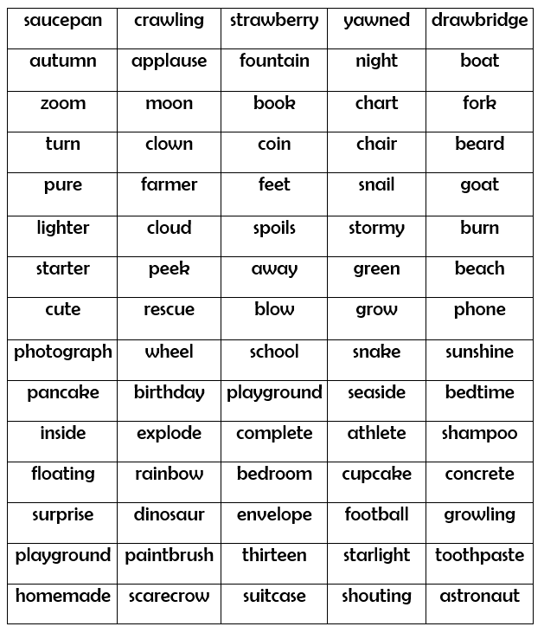
Real words:



